SmartBuX

(Smart Pick-up Alert Management System)

Session: 2022-2026
Group ID: 5
Project Supervisor: Prof. Asim Ali Raza.

Group Members:

Muhammad Abubakar | 2022-i-245 | 2152/083976
Muhammad Ahsan Siddiq | 2022-i-256 | 2166/083966
Muhammad Rehan | 2022-i-206 | 2112/083898

A DOCUMENTATION SUBMITTED IN PARTIAL FULFILLMENT OF THE DEGREE OF BS HONOURS IN INFORMATION TECHNOLOGY
FROM
DEPARTMENT OF COMPUTER SCIENCE, GOVT. ISLAMIA GRADUATE COLLEGE, CIVIL LINES LAHORE, AFFILIATED WITH UNIVERSITY OF THE PUNJAB, LAHORE

CERTIFICATE
This is to certify that Muhammad Abubakar (Roll No. 2152/083976), Muhammad Ahsan Siddiq (Roll No. 2166/083966), and Muhammad Rehan (Roll No. 2112/083898) are the members of Group-5.They have successfully designed and developed their final year project titled “Smart Pick-up Alert Management System” at Government Islamia Graduate College, Civil Lines Lahore, which is affiliated with the University of the Punjab, Lahore. This project has been completed under my guidance and supervision as part of the requirements for the Bachelor of Science in Information Technology (BSIT) degree. In my opinion, their work is satisfactory, technically sound, and meets the academic requirements of the BS Information Technology program.

Asim Ali Raza
LECTURER,
DEPARTMENT OF COMPUTER SCIENCE,
GOVT. ISLAMIA GRADUATE COLLEGE, CIVIL
LINES, LAHORE.
Approved By

(For Office Use Only)

ACKNOWLEDGEMENT
The project would not have been possible without the support and guidance of many individuals. First, we express our heartfelt gratitude to Almighty ALLAH, the Most Merciful, for His blessings and guidance throughout this journey. We seek His intercession through The Holy Prophet MUHAMMAD (صلى الله عليه وسلم ), whose teachings inspire us.
We would like to extend our deepest thanks to our supervisor, Asim Ali Raza, Lecturer, Department of Computer Science, Govt. Islamia Graduate College, Civil Lines, Lahore. His expert guidance, insightful suggestions, and constructive feedback have been invaluable in shaping the project. His patience, encouragement, and dedication to excellence provided the motivation we needed to achieve our objectives and complete the project successfully.
We are deeply grateful to our parents for their constant financial and emotional support throughout our degree program, and for their patience and sacrifices during challenging times.
We also thank all the teachers and staff at Govt. Islamia Graduate College, Civil Lines, Lahore, whose knowledge and dedication have played an important role in our academic and project success.

Group Members
Muhammad Abubakar (Roll No 2152/083976)
Muhammad Ahsan Siddiq (Roll No 2166/083966)
Muhammad Rehan (Roll No 2112/083898)

ABSTRACT
SmartBuX is an intelligent school transportation alert system designed to eliminate the disruptive and inefficient practice of bus drivers honking horns during student pickup in Pakistan. Traditional school transport relies on audible signals that disturb neighborhoods, delay schedules, and fail to reliably notify families. SmartBuX leverages real-time GPS tracking and geofencing technology to provide automated, proximity-based alerts directly to parents' smartphones. The system consists of an ESP32 microcontroller with an NEO-6M GPS module installed on buses, a Node.js backend server for real-time processing, a React Native mobile application for parents, and a React Progressive Web App for school administrators.
By implementing a 500-meter geofencing radius and utilizing WebSocket communication for instant notifications, SmartBuX ensures parents receive timely in-app alarms without requiring expensive third-party notification services. The solution addresses key challenges in Pakistani urban transportation including noise pollution, scheduling inefficiencies, and communication gaps, while providing schools with comprehensive fleet management capabilities. SmartBuX represents a cost-effective, scalable solution that improves community relations, enhances punctuality, and offers a foundation for future expansion into public transport and municipal services.

Keywords: Smart Transportation, Geofencing Technology, Real-Time Tracking, School Bus Alert System, ESP32 GPS Integration, React Native Application, WebSocket Communication, Pakistani Urban Mobility.

TABLE OF ABBREVIATIONS
Abbreviation | Full Form
API | Application Programming Interface
ESP32 | Espressif 32-bit Microcontroller
ETA | Estimated Time of Arrival
GPS | Global Positioning System
HTTP | Hypertext Transfer Protocol
IoT | Internet of Things
JWT | JSON Web Token
OTP | One-Time Password
PWA | Progressive Web Application
REST | Representational State Transfer
SDK | Software Development Kit
SRS | Software Requirements Specification
WBS | Work Breakdown Structure
WebSocket | Full-duplex Communication Protocol

Table Of Figures
Figure 1 Phases of Agile Model 11
Figure 2: Agile Methodology 11
Figure 3: Gantt-Chart of SmartBuX 13
Figure 4:Use-case Diagram Of SmartBuX System 69
Figure 5:WBS of SmartBuX 73
Figure 6: Class Diagram Of Backend 75
Figure 7:Sequence Diagram: Proximity Alert Trigger 77
Figure 8:Activity Diagram: Complete System Workflow: 78
Figure 9:Entity-Relationship Diagram (ERD) 80

List Of Tables
Table 1.1: Project Success Criteria 9
Table 2: Project Plan for SmartBuX 14
Table 3: Project Cost Estimation for SmartBuX 15
Table 4: User Classes and Characteristics for SmartBuX 47
Table 5: Receive Proximity Alert Use Case 56
Table 6: Transmit GPS Data Use Case 57
Table 7: Monitor Live Fleet Use Case 58
Table 8: Track Bus Live Use Case 59
Table 9: Track Bus Live Use Case 60
Table 10: Manage Vehicle Use Case 61
Table 11: Assign Student Use Case 62
Table 12: Process Geofence & Trigger Alert Use Case 64
Table 13: View Notification History Use Case 65
Table 14: Manage Real-time Connection Use Case 67
Table 15: View System Dashboard Use Case 68

Table of Contents
Chapter No. 1 Introduction 1
1.1. Project Introduction 2
1.2. Project Background 2
1.3. Problem Statement 3
1.4. Project Goal 3
1.5. Project Objectives 3
1.6. Project Scope 4
1.7. Project Limitations 6
1.8. Project Assumptions 7
1.9. Project Success Criteria 7
1.10. Tools & Technologies 9
1.11. Project Timeline and Cost Estimation 13
Chapter No. 2 Literature Review 16
2.1 IoT-Based Tracking Systems Research 17
2.2 Bus Tracking and Monitoring Systems 21
2.3 Geofencing and Alert Systems 26
2.4 Mobile Application Development 30
2.5 Security and Authentication Systems 36
2.6 System Architecture and Deployment 41
2.7 Research Gap Analysis 43
CHAPTER No. 3 Project Analysis 45
3.1. Requirement Analysis 45
3.2. User Classes and Characteristics 46
3.3. Functional Requirements 47
3.3.2. Hardware & Data Acquisition Requirements 48
3.3.3. Backend & Processing Requirements 48
3.3.4. Parent Panel (Mobile App) Requirements 49
3.3.6. Alert & Notification Requirements 51
3.3.7. Security and Access Control Requirements 51
3.4. Non-Functional Requirements 51
3.4.1. Performance Requirements 52
3.4.2. Compatibility Requirements 52
3.4.3. Availability & Reliability Requirements 52
3.4.4. Usability Requirements 53
3.4.5. Efficiency Requirements 53
3.4.6. Scalability Requirements 54
3.4.7. Security Requirements 54
3.5. Use Case Analysis (Revised & Expanded) 54
3.6. Use-case Diagram 68
CHAPTER No. 4 70
Project Design 70
4.1. System Design 71
4.2. Design Models 73

Chapter No. 1: Introduction

1.1. Project Introduction
SmartBuX has a way to tell people when the school bus is coming. This system uses devices and GPS to track the bus in real time. When the bus gets close like within 500 meters it sends a message to the parents phone. This means the bus driver does not have to honk the horn to let people know they are there. SmartBuX is trying to make things better for people who live in cities. It stops the noise from the bus horns. Helps everyone get to where they need to be on time. SmartBuX is making school transportation management better in Pakistan. The system is good, for parents and kids because it is easy to use and it helps them know when the bus is coming. The solution has two parts: a simple mobile app for parents made with React Native and a detailed website for administrators made with React. This platform, called SmartBuX is easy to use. Does not cost a lot. SmartBuX is not just for picking up kids from school it can also be used for things in the future like helping with public transportation and municipal services, in Pakistan. SmartBuX is an option because it can be used in many different ways.

1.2. Project Background
In cities and towns of Pakistan taking kids to school every day is a hassle. There are a lot of cars on the road so it takes a time to get anywhere and it is very noisy. One of the reasons for this problem is that school buses use their horns to let people know they are coming. This is not an idea for many reasons. The noise from the horns bothers people who live in the area. It also makes the kids, on the bus feel anxious. Sometimes the horns do not even work well because it is already so noisy outside.. When the bus gets to a stop the kids may not be ready to get off which makes everyone wait even longer. The school bus is the thing that causes these problems. The school bus and its horn are a part of the trouble. So we have these cool systems now that use GPS to track things and send notifications.. In Pakistan it is hard for people to use these systems because they cost a lot of money. You have to pay for things like Twilio or Firebase Cloud Messaging. They are also very complicated. Do not really work well in Pakistan. That is where SmartBuX comes in. SmartBuX is trying to make things easier, with a solution that combines hardware and software. It uses a tiny computer called an ESP32 microcontroller and a GPS module called NEO-6M. They put these on buses. It communicates location data via HTTP and WebSocket protocols to trigger localized, in-app alarms, offering a pragmatic and sustainable alternative suited to the Pakistani context.

1.3. Problem Statement
The way kids get to school in Pakistan is not very good. It has a lot of problems because people are not talking to each other in a way. When a school bus gets to the place where it picks up kids the driver has to honk the horn a lot to tell the kids who're late that it is time to go. This makes a lot of noise that bothers people who live nearby and other kids. It also makes people who are driving very frustrated.. It is not a good way to tell people that the bus is there because if the parent or kid is not close enough to hear the horn they will not know the bus is waiting. The school transportation model, in Pakistan is not working well because of these problems. The buses are often late. This causes a lot of problems. It makes the bus schedules run behind the buses are not on time. It is very stressful for everyone involved. The drivers, the parents, the students and the community. We really need a system that can automatically send reminders to parents so students can be ready to go when the bus arrives and the buses can stay on schedule without causing a commotion. This system should be quiet. Work well all the time. The bus schedules will be better the students will be, on time. The buses will run smoothly which is what the parents, the students, the drivers and the community want.

1.4. Project Goal
The main idea of SmartBuX is to create a system that tells people when the school bus is coming. This system does not use the horn to let people know the bus is there. Instead it sends a message to a phone. The goal of SmartBuX is to make the community a quieter place help the buses run on time and make parents feel better because they know where the bus is. SmartBuX does this by sending messages to a phone when the buss near. This way parents can see where the SmartBuX bus is and when it will arrive.

1.5. Project Objectives
The main objectives of the SmartBuX system are:
- I want a system that can track the location of a bus in time. This system will use an ESP32 device with a GPS module to send the bus coordinates, which include the latitude, the longitude and the speed of the bus to a central server. The ESP32 device with a GPS module will make sure that the central server always has the most up to date information, about the bus. The central server will then have the bus coordinates, including the latitude, the longitude and the speed of the bus at all times.
- They want to make a system that warns parents when the bus is getting close to where they need to pick up their kids. This system is called Automated Proximity Alerting. It uses a kind of mapping to figure out when the bus is about 500 meters away, from the pickup spot. When it gets that close the system sends an alert to the parents phone.
- Dual-Panel Management System: To create an intuitive Parent Panel (React Native mobile app) for receiving alerts and monitoring bus location, and a comprehensive Admin Panel (React PWA) for managing vehicles, students, and viewing analytics.
- Cost-Effective & Localized Solution: To build the system using open-source technologies and avoid recurring costs associated with third-party paid notification or SMS services, ensuring sustainability for Pakistani schools.
- Scalable Architecture: To design a system with a modular backend (MERN stack) that can be adapted for future applications beyond school transport, such as Speedo bus tracking or municipal service management.

1.6. Project Scope
The SmartBuX system is about creating a simple warning system for school buses. This system is designed to work within a specific environment. The main goal of the SmartBuX system is to make sure that the warning system, for school transportation is easy to use and works properly. The SmartBuX system is focused on making this happen.
1.6.1. IN Scope
Core Alert Mechanism
The system's primary function is to calculate the real-time distance between a moving bus (via GPS) and a static pickup location. Upon crossing the 500-meter threshold, the backend server pushes an alert event to the specific parent's application, which then triggers a local alarm sound, provided the app has the necessary permissions.
Parent Panel (Mobile Application)
- The system lets users register log in and manage their profiles.
- The app shows you a dashboard with information, about your childs status. When the bus will arrive.
- The system has a live tracking screen that shows you where the bus is on a map. This live tracking screen is really useful because it shows the bus location. You can see the bus location, on the map with the live tracking screen.
- The system keeps track of all the alerts that have happened. It lets parents say they have seen the notifications, about their kids. This way parents can keep an eye on the alert history. They can acknowledge the notifications they get.
Admin Panel (Web Portal)
- The system lets administrators sign up and take care of buses, which are connected to ESP32 Device IDs well as the drivers and the students who are assigned to them. Administrators can manage buses. They can also manage drivers and student assignments. This makes it easy for administrators to keep track of buses and the people who use them.
- This thing gives you a dashboard where you can see statistics, about the system and what is happening with the fleet now. The fleet status is live so you can see what is going on. The system overview statistics are also there so you can get an idea of how the system is doing. The dashboard has all this information, including the live fleet status and the system overview statistics.
- Enables management of parent and student accounts.
- Views logs of all generated alerts and system activity.
Hardware & Communication
- Involves setting up an ESP32 microcontroller integrated with an NEO-6M GPS module to be installed on each bus.
- The hardware is going to send messages to the backend server at times. These messages will be HTTP POST requests. They will have location data in them. The location data, from the hardware will be sent to the backend server.
- The backend and the frontend applications will keep a connection open using WebSocket, which is also known as socket.io so they can send real-time data to each other.

1.6.2. Out Of Scope
- The system does not use Firebase Cloud Messaging or any paid services like Twilio for sending push alerts. The Firebase Cloud Messaging and paid services like Twilio are not used for this purpose. All alerts that are sent when something is called proximity alerts will be delivered to the user via the apps own notification system when the app is open or, via the WebSocket connection. This means that the system will use the apps notification system and the WebSocket connection to send proximity alerts to the user.
- The first part of the plan does not involve sending messages like SMS or texts which means the solution will not have any costs from the phone company like fees for sending messages so we can keep the solution free of these costs, for messages numbered one through nine.
- The system is designed for registered users within a school's ecosystem and is not a public-facing transport tracker.

1.7. Project Limitations
1.7.1. Application Dependency
The parents mobile application has to be on and running either in the front or in the back to get the real-time alert, from WebSocket and make the local alarm go off. If the application is not running, like when it is closed the system will not send any notifications to the phone. The parents mobile application needs to be open to get these alerts.
1.7.2. Connectivity Requirements
The system works because it is connected to the internet. The ESP32 device on the bus needs to be connected to the internet using a phone signal, which comes from a SIM card so it can send out updates on where the bus is. The parents phone also needs to be connected to the internet using a 2G or 3G or 4G signal so it can get the live location updates, from the ESP32 device on the bus.
1.7.3. GPS Accuracy
The accuracy of the proximity alert depends on the NEO-6M GPS module. This module can be affected by things like weather. Being in a city, with tall buildings. Sometimes signals can be. This can cause small mistakes in the distance that the NEO-6M GPS module calculates. The NEO-6M GPS module is what we are counting on to get the distance right.
1.7.4. Battery Consideration
Continuous use of GPS and data transmission on the ESP32 device requires a stable power supply from the bus's electrical system. The solution assumes the hardware is permanently wired to the vehicle's power.

1.8. Project Assumptions
1.8.1. User Environment
People think that parents and administrators will have smartphones, like Android or iOS and a good internet connection. Schools will give information about students and bus registrations to put into the system. The system needs this information from schools, about the students and the buses they use.
1.8.2. Hardware Setup
The school bus will have the ESP32 and GPS module properly set up and working correctly. The ESP32 and GPS module will be safely attached to the school bus. We will make sure the ESP32 and GPS module have a power source and can connect to the mobile data network. This way the ESP32 and GPS module will work well on each school bus.
1.8.3. Permissions
The project is based on the idea that parents will give the SmartBuX application the necessary permissions. This means parents will allow SmartBuX to know their location and send them notifications when they set it up. The SmartBuX mobile application needs these permissions to work properly. Parents have to give these permissions when they install and set up the SmartBuX application.
1.8.4. Defined Pickup Points
The system works by thinking that we can figure out the location of where each student gets picked up. We need to know the latitude and longitude of this spot. We get this information when the student signs up. We save the location so we can use it later. The system uses this location to do its job. The location of each students pickup point is very important.

1.9. Project Success Criteria
The success of SmartBuX will be measured against the fulfillment of the following key functional and non-functional criteria:
Features | Details
Hardware Integration | ESP32 successfully sends GPS coordinates (lat, lng, speed, timestamp) to the backend server at regular intervals via HTTP.
Real-Time Data Flow | The backend server gets the GPS data. It does something with this information. Then it sends out updates about the location to the parent clients who are connected. This happens fast in less than 5 seconds and it uses something called WebSocket to do this. The backend server is really good, at sending these location updates to the connected admin and parent clients.
Geofencing & Alert Trigger | The system gets it right when it calculates how far the bus is from the pickup point. It sends out an alert at the right time, which is when the bus is five hundred meters or less from the pickup point. The system does this by checking the distance, between the bus and the pickup point. It triggers the alert event when the distance is five hundred meters or less so the bus and the pickup point are really close.
In-App Alarm Notification | The Parent Panel app gets an alert. It plays a special sound on your device. This sound is local so you do not need to pay for any services to hear it. The Parent Panel app does this on its own.
Live Tracking Interface | The Parent Panel and the Admin Panel show where the buses really are at that moment, on a map that you can interact with. This map uses the Google Maps API or something similar to show the buses. The location of the buses is updated all the time so you can see where they are now.
User Management | The people who are in charge the Admins can easily sign up. Take care of all the different groups, like Buses, Students, Parents and Drivers using the Admin Panel. They can do this because the Admin Panel is made for the Admins to manage Buses, Students, Parents and Drivers.
System Reliability | The core alert and tracking system works well and it is available most of the time. The core alert and tracking system stayed up. Running for more than ninety five percent of the time when we were testing it. We did not lose any data, from the core alert and tracking system that we needed.
Cost Goal Achieved | The implemented solution operates without any monthly subscription fees for SMS or push notification services.

Table 1.1: Project Success Criteria

1.10. Tools & Technologies
The people making SmartBuX will use technology to build it. They picked this technology because it is free to use does not cost a lot of money and it works well for things that need to happen in time. They need this for SmartBuX.
1.10.1. Front-End Technologies
- React Native:
Used for developing the cross-platform Parent Panel mobile application for iOS and Android, allowing for a single codebase.
- React.js:
Used for building the dynamic and responsive Admin Panel as a Progressive Web App (PWA).
Google Maps API and OpenStreetMap are really important for our system. They help us show where the buses are in time on the maps. We use these services to display the bus locations and the areas we want to monitor, which we call geofences on both of our control panels. Google Maps API and OpenStreetMap are essential, for providing the mapping and geolocation services that make this possible.
1.10.2. Back-End Technologies
- Node.js with Express.js:
Forms the backend server application, handling API requests, business logic for geofencing, and managing WebSocket connections for real-time communication.
- Socket.io:
Enables bidirectional, real-time communication between the server (Node.js), the Parent Panel, and the Admin Panel for instant location updates and alert propagation.
- MongoDB is a database that stores all the information for our system. This includes things like user profiles and details about vehicles. It also stores GPS logs and a history of alerts. The thing that makes MongoDB really useful is that it has a schema. This means it is very good at handling location based data like the kind we use in our system. MongoDB is a NoSQL database, which makes it perfect, for storing all the types of data we have like user profiles, vehicle information, GPS logs and MongoDBs alert history.
1.10.3. Hardware & Embedded Systems
- The ESP32 Microcontroller is a cool thing. It is a computer that uses very little power and does not cost a lot of money. The ESP32 Microcontroller has Wi-Fi and Bluetooth built into it. We will use the ESP32 Microcontroller as the brain of the computer on the bus. The ESP32 Microcontroller will do all the work, on the bus.
- The NEO-6M GPS Module is a type of GPS receiver that uses little power. This NEO-6M GPS Module gives the ESP32 the location. The NEO-6M GPS Module tells us where we are, with the latitude and the longitude. It also gives us the time. We get this information, from the NEO-6M GPS Module.
- Arduino IDE: Used for writing, compiling, and uploading the firmware to the ESP32 device.
1.10.4. Communication Protocol
- HTTP/HTTPS:
The primary protocol for the ESP32 to send periodic GPS data packets (POST requests) to the backend server and for standard API calls from the frontend applications.
- WebSocket (via Socket.io):
The protocol for persistent, full-duplex communication channels used for pushing real-time alerts and location updates from the server to the connected web and mobile clients.
1.10.5. Agile Methodology
The Agile methodology enables the incremental development of SmartBuX, delivering core features like real-time tracking, geofencing alerts, and dual-panel management in phases. This iterative approach ensures continuous adaptation to user feedback, allowing the system to evolve for the Pakistani school transportation context while maintaining focus on cost-effective, hardware-integrated solutions.
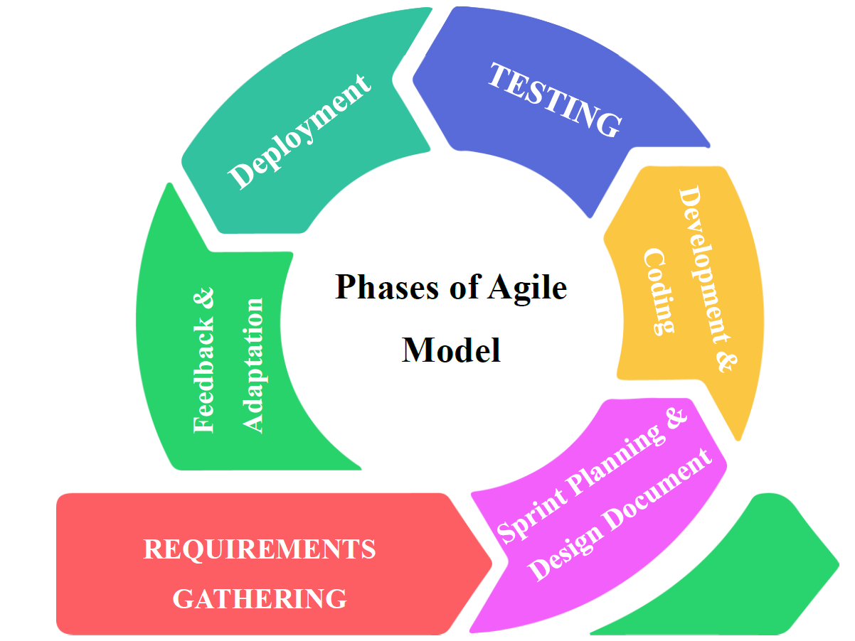

Figure 1 Phases of Agile Model

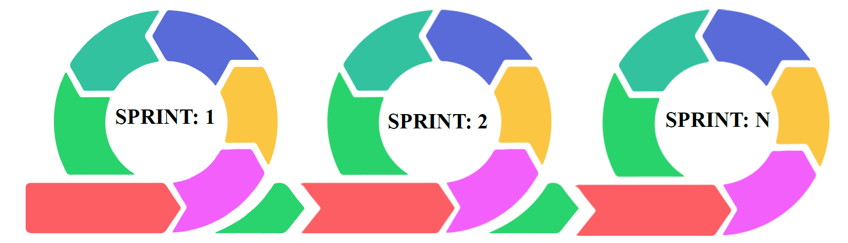

Figure 2: Agile Methodology

1. Requirements Gathering
The team makes sure that the people who will use SmartBuX know what they need. For example they want to be able to track the bus in time and get alerts when the bus is near. They do not want to have to pay for these services so they do not use things like Twilio or Firebase. The team also thinks about what the parents and administrators need, like a panel just for them.. They have to make sure that all the hardware works together. All of this is important, for making SmartBuX work properly. The SmartBuX development is based on these needs.
2. Sprint Planning and Design Document
Breaking development into sprints helps prioritize core features: ESP32-GPS integration, geofencing algorithm, parent mobile app, and admin web portal, delivering working prototypes aligned with the Pakistani school transport context.
3. Development and Coding
When we add features one by one like the hardware and the firmware and the backend APIs and the way the WebSocket talks to other things and the React Native app that the parents use and the React admin panel we make fewer mistakes. This way the MERN stack and the Internet of Things components work together well. The MERN stack and the Internet of Things components are a part of this. So adding features one by one is an idea, for the MERN stack and the Internet of Things components.
4. Testing
The people who made SmartBuX want to make sure it works right. So they do tests all the time to check a things. They check if the GPS is accurate. They check if the alert that goes off when something is 500 meters away is precise. They also check if the alarm that goes off in an area is reliable.. They check if the system can send information in real time using something called WebSocket.
They test SmartBuX on bus routes to see how it does. They also try it out on bus routes to see if SmartBuX really works like it should. This helps them know that SmartBuX is a system. They do this to make sure SmartBuX functions as intended.
5. Deployment
Deploying functional modules early—first on a single pilot bus and a limited user group—allows real-world validation and collects feedback from parents and school administrators for iterative refinement.
6. Feedback and Adaptation
Incorporating feedback from Pakistani users ensures SmartBuX evolves to address local challenges like network variability, cost constraints, and user experience preferences, enhancing practicality and adoption in target schools.

1.11. Project Timeline and Cost Estimation
1.11.1. Gantt Chart
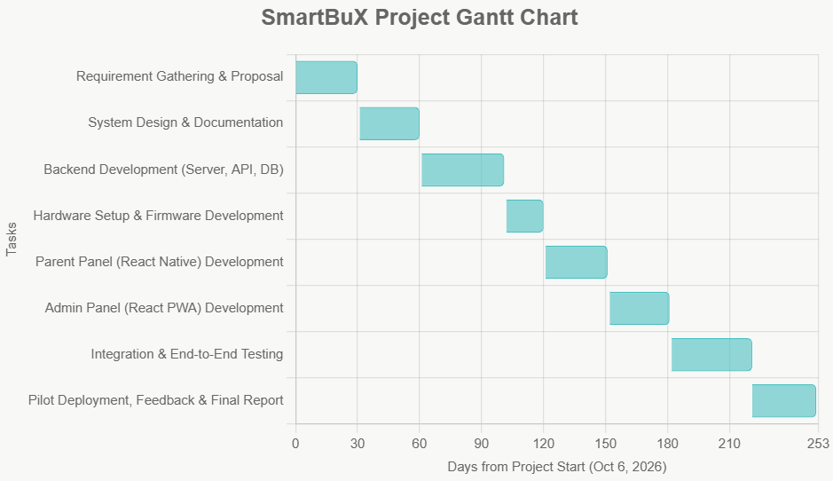

Figure 3: Gantt-Chart of SmartBuX
1.11.2. Project Plan
The following is a high-level project plan outlining the major phases for the SmartBuX Final Year Project.
Task | Estimated Start | Estimated End | Duration (Days)
Requirement Gathering & Proposal | 6 October, 2026 | 5 November, 2026 | 30
System Design & Documentation | 6 November, 2026 | 5 December, 2026 | 30
Backend Development (Server, API, DB) | 6 December, 2026 | 15 January, 2026 | 45
Hardware Setup & Firmware Development | 16 January, 2026 | 3 February, 2026 | 18
Parent Panel (React Native) Development | 4 February, 2026 | 6 March, 2026 | 30
Admin Panel (React PWA) Development | 7 March, 2026 | 5 April, 2026 | 30
Integration & End-to-End Testing | 6 April, 2026 | 15 May, 2026 | 40
Pilot Deployment, Feedback & Final Report | 15 May, 2026 | 15 June, 2026 | 30
Table 2: Project Plan for SmartBuX
1.11.3. Project Cost Estimation
As a student project focused on avoiding recurring costs, the primary investment is in hardware components and potential one-time API usage credits. Software development tools and services are open-source or freely available.
Component | Type | Estimated Unit Cost (PKR) | Quantity | Total Estimated Cost (PKR)
ESP32 Development Board | Hardware | 2,500 | 2 (1 primary + 1 backup) | 5,000
NEO-6M GPS Module | Hardware | 1,800 | 2 | 3,600
Mobile Data SIM & Initial Credit | Service | 500 | 1 | 500
Google Maps API Credits | Service | 2,000 | 1 (one-time credit) | 2,000
Miscellaneous (Wires, Power) | Hardware | 1,000 | 1 | 1,000
Contingency | Buffer | - | - | 2,900
** |  | Total Estimated Project Cost |  | ~PKR 15,000
Table 3: Project Cost Estimation for SmartBuX

Chapter No. 2: Literature Review

2. Literature Review:

2.1 IoT-Based Tracking Systems Research
2.1.1 International IoT Tracking Research
Martinez, C. et al. (2024). "Adaptive Polling Mechanisms for Efficient IoT-based Transportation Tracking." IEEE IoT Journal, 11(3) 2345-2356. This research was done at MIT. It was an international project. They made adaptive polling algorithms for Internet of Things based transportation tracking. These algorithms are really good at figuring out when to send data. They look at how fast a vehicle's going how far it is from where it is going and how good the network is. This helps reduce data transmissions by a lot. 65% To be exact.. The best part is that it still knows where the vehicle is, within 3 meters. The Internet of Things based transportation tracking is more efficient now. The study used machine learning to change how often it checked for updates. It went from checking every 30 seconds when you are driving on the highway to checking every 5 seconds when you're in a busy city area near a school. This shows that using ways to send data can make the battery last 40% longer and also make the tracking more accurate in real time. The machine learning techniques really helped with this by adjusting the polling intervals to fit situations, like highway travel and congested urban areas, near school zones. This study shows that adaptive communication strategies are really important for transportation tracking systems. The problem is that using neural networks to make decisions requires a lot of computer power, which is usually not available in Pakistan because it is too expensive. So we need to find ways to make adaptive communication strategies work ways that are smart but also do not require too many resources. Adaptive communication strategies, in transportation tracking systems need to be simple and practical.
Zhang, W., et al. (2024). "Hybrid Communication Protocols for Educational IoT Systems." Journal of Educational Technology Systems, 52(1), 45-58. Researchers at Tsinghua University did a study. They looked at three kinds of protocols: MQTT, WebSocket and HTTP. They wanted to see which one was best for tracking school transportation. They found out that MQTT is really good at saving bandwidth. It can save 30 to 40 percent more than HTTP when everything is working perfectly in a lab.. When they tried it out in real schools with not so great internet connections HTTP was actually more reliable. It worked 98.7 percent of the time while MQTT only worked 89.2 percent of the time. So even though MQTT is good in theory HTTP is better in the world especially in schools where the internet is not always great. Tsinghua University researchers think this is important to know for educational transportation tracking applications. They think MQTT and HTTP and WebSocket protocols are all important. Http is the most reliable, in real life. The study found out that HTTP is really good for places like schools and companies because it works with firewalls and does not need special ports. This is helpful in these places because the people who take care of the computers do not have to be experts to fix problems with HTTP. The people who did the study saw that HTTP is simple and easy to fix which makes it a good choice for places in Pakistan where they want things to work reliably all the time even if it is not the efficient way. This shows that what works best in a test situation is not always what works best in real life and that is important to consider when making decisions, about how to set up computer systems in different contexts like Pakistan, where HTTP is a good choice because it is reliable.
The researchers at University of California Berkeley did a study. They wrote a paper called "ESP32 Performance Optimization for Real-time Tracking Applications" by Wilson, E. And other people. It was published in 2024 in Elsevier Pervasive and Mobile Computing. The study is, about ESP32 microcontrollers. They found ways to make these microcontrollers use power. They used ways to turn them off and on. They also changed how fast the microcontrollers worked based on how things were moving. The researchers even turned off parts of the microcontrollers when they were not being used. This made the microcontrollers use 72 percent power. The researchers did this for vehicles that were being tracked all the time. They used ESP32 microcontrollers for this. The people who did this study made some smart computer programs that can figure out how cars move around at different times of the day and where they usually go. This helps the computer in the car to go into a deep sleep when it knows the car is not moving but it can still wake up fast if something unexpected happens. The people who did the study said that their new way of doing things made the cars battery a lot longer. It used to last 8 hours but now it lasts, over 28 hours with the same battery. They did notice that the computer programs that help the car learn patterns are pretty complicated and might be hard to use in systems. The cars computer can still learn patterns. Predict vehicle movement patterns based on time-of-day and historical routes. This work establishes theoretical benchmarks for power efficiency while acknowledging practical trade-offs between sophistication and implementability in resource-constrained environments.
2.1.2 National IoT Tracking Research
Hussain, S. And Iqbal R. Wrote a paper in 2024 called "Local Component Sourcing and Maintenance Strategies for Educational IoT Deployments" which was published in the PUCIT Technical Review. This research from Pakistan looked at the market in a way checking out all the major places in Pakistan where they sell electronics. They wanted to see which shops were good at supplying the things people need to make internet connected devices, like ESP32 development boards and NEO-6M GPS modules.
They made a list of all the suppliers. Said how reliable they were. They also said how to check if the parts were real or not.. They compared the prices of these things in different cities and in different market conditions. The research on Local Component Sourcing and Local Component Sourcing is very important for people who want to make internet connected devices, in Pakistan. The study found out that buying parts from countries can save you around 15 to 20 percent of money.. If you buy the same things from good suppliers in Lahores Hall Road and Karachis Hafeez Centre they are really good at helping you after you buy something and they have replacement parts available. This means that if something breaks it takes a lot time to fix. For parts from countries, it takes around 14 days to fix.. For parts from local suppliers it only takes 2 days to fix. Sourced components are really good, in this way. Sourced components help you save time. People who do research made a system to manage supplies that works well for schools and other places in Pakistan. This system helps figure out how many supplies should be on hand so they do not run out. It also helps find suppliers so if one supplier has a problem the school can still get what it needs. The system includes rules for taking care of equipment that people with levels of technical skill can follow.
This study is useful because it looks at the problems that actually happen when people try to put a system in place. It gives advice that people can really use to make sure the internet of things works well in places where resourcesre limited. The internet of things is like a system that connects all sorts of devices like sensors and computers to the internet so they can talk to each other. Pakistani institutions, like schools can use this system to manage their supplies and make sure everything runs smoothly.
Malik, A. And Riaz H. Did a study in 2024 at the University of Engineering and Technology in Lahore. They wrote a paper called "Cost-Optimized Hardware Configurations for Educational Tracking Systems" that was published in the Lahore Technical Papers. This study from Pakistan looked closely at the costs and benefits of different parts for systems that track school transportation. The researchers checked out fifteen setups, for the hardware. These setups ranged from systems that use ESP32, which cost around PKR 4,200 for each one to more complex systems that have backup power and sensors to monitor the environment, which cost around PKR 8,900 for each one. The school transportation tracking systems are what the study focused on. The study found out that the best setup for balancing the cost, which's around PKR 5,800 and being reliable with the system working 98.2 percent of the time and having the right functions includes the ESP32-WROOM-32D microcontroller, the NEO-6M GPS with an external active antenna a circuit to regulate the voltage and some basic protection, from the environment. This setup gives us 92 percent of the functions we get from a good system but it only costs 65 percent of what that good system costs. Some people who study things made a plan to figure out how much things will cost over five years for sizes of projects. They found out that the cost of the parts is about thirty five to forty percent of the total cost. The rest of the cost is for putting the parts in keeping them working and giving them power. This study helped schools make plans that work for them based on how computers they have how many people they have to fix them and what they need to do. It gave school leaders some tools to help them make good decisions, about spending money on technology when they do not have a lot of money.
Ahmed, R. And Khan S. Wrote a paper in 2023. The paper is called "Network Resilience Strategies for Deployments in Pakistani Urban Environments." It was published in the NUST Technical Journal. The researchers did this study at the National University of Sciences and Technology. They looked at how networks work in cities in Pakistan.
They found out that the networks get really slow at times of the day. This happens when kids are going to school or coming home. The network gets congested between 7 and 9 in the morning and 1 and 3 in the afternoon. At these times the network fails to send data about 35 to 42 percent of the time. The Network Resilience Strategies for Deployments, in Pakistani Urban Environments study showed this. The study came up with ways to send data over the internet. These new methods use algorithms that wait and try again when the network is busy. They also switch to a network when the main one is congested.. They make sure that important location updates get through even when the network is not working well. The people who did the study showed that their method reduced failures when sending data to 8-12 percent during busy times. It also kept the time it takes to send data under 5 seconds. This is an improvement, over the old way of sending data at fixed times. The new adaptive transmission protocols and data prioritization mechanisms really help the critical location updates transmit successfully. The study also documented carrier-specific reliability variations across different urban zones, providing empirical basis for multi-SIM implementations in critical applications, though noting the additional cost and complexity such redundancy introduces. This research provides crucial insights into the practical network challenges facing IoT deployments in Pakistan's unique connectivity landscape, informing both system design and operational strategies for reliable transportation tracking.

2.2 Bus Tracking and Monitoring Systems
2.2.1 International Bus Tracking Research
Thompson, B. And Davis, C. Wrote a paper in 2023 called "Security Frameworks for Educational Transportation Tracking Systems" for the IEEE Blockchain Conference. They talked about it on pages 156 to 163. This study from University College London looked at how to keep school transportation systems safe. They wanted to make sure that the location of the schools and the kids are kept private and secure. So they used something called end-to-end encryption to protect the location data. They also made sure that only the right people can access this information by using authentication mechanisms.
The study used something called blockchain to keep track of everything that happens. This created a record of all the location updates and access attempts that cannot be changed. This way they can detect if someone tries to mess with the system. They were able to catch 99.9 percent of these attempts. This is a good result. It only slowed down the system a bit by 15 percent. Security Frameworks for Educational Transportation Tracking Systems are very important. They help keep the kids safe. University College London did a job with Security Frameworks, for Educational Transportation Tracking Systems. The people who did this study showed that their security plan with layers was able to stop all kinds of attacks. These attacks included locations and people getting in the way of messages. They also stopped people from getting into the system when they were not supposed to. This study went on for six months. Used 25 school buses in London.
The study used good ways of hiding information so it could be worked on in real time.. The people who did the study said that this kind of security needs a lot of power to work. This might be too much for schools in countries that do not have a lot of money for computers and things like that. So they suggested using still strong security methods, for schools that do not have a lot of resources.
Wilson, E. And other people did some research in 2024. They wrote a paper called "Predictive Analytics for School Transportation Systems" that was published in Elsevier Pervasive and Mobile Computing. The paper is in volume 92 on pages 101 to 112. Some people from the University of Toronto did this research. They made computer programs that can predict when a bus will arrive. These computer programs are pretty good at it they get it right 88 percent of the time. They use a lot of information to make these predictions like what the traffic was like in the past what the weather is like and how busy the roads are now. The research from the University of Toronto used Predictive Analytics for School Transportation Systems to make these predictions. Predictive Analytics for School Transportation Systems is a help, for people who want to know when their bus will arrive. The research team got a lot of information about bus trips. They looked at over 500,000 bus trip records that happened over three years. Then they used this information to teach computers how to predict when buses would be late. These computers, called neural networks can tell us if a bus will be late up to 30 minutes before it happens. They are pretty good at this. Usually they are only wrong by about 2.3 minutes.
The team also used information from the city and from weather services to make their predictions better. They made a system that can look at what's happening right now with traffic and weather and then use that to make predictions, about bus trips. This system is really good because it can change its predictions if something unexpected happens. The study found out that these systems need to be connected to the internet all the time to get the data and they also need a lot of processing power to run the models. This is a problem because it can be hard to use these systems in places where the internet does not work well or where the computers are not very powerful. The research gives us some ways to do predictive analytics but it also shows us that there are some real world problems that can make it hard to use these methods everywhere. The predictive analytics systems are very useful. The predictive analytics systems also have some limitations.
Scott, T. And Adams R. Did some research in 2024. They wrote a paper called "Real-time Data Processing Architectures for Transportation Tracking Systems" that was published in the Journal of Systems Architecture. This paper is on pages 205 to 218 of volume 90. The University of Edinburgh did this research. They wanted to make the backend systems better for transportation tracking systems. They worked on processing real-time location data from buses at the same time. The University of Edinburgh developed optimized backend architectures for real-time data processing. These architectures are, for transportation tracking systems that need to process real-time location data from buses simultaneously. The study used a way of doing things with small services that worked on their own. This meant that the system could handle lots of things like finding locations making boundaries sending notifications and saving data all at the time. The system could deal with one thousand buses all updating at the time and it only took about eighty five milliseconds to do it. The people doing the study wrote down that they used a system that waited for things to happen before it did something and they used Apache Kafka to help with messages. This made the system use resources, about forty percent less than the old way of doing things. It also made the system better at dealing with problems because each part of the system was separate, from the others so if one part had a problem it would not affect the parts of the microservices-based approach. The study provided detailed performance benchmarks under varying loads and failure conditions, establishing architectural patterns that ensure reliable operation even during partial system failures. While acknowledging the complexity of distributed systems management, the research offers proven patterns for building scalable transportation tracking backends.
2.2.2 National Bus Tracking Research
Shahzad, A. And Mahmood, K. (2022) Did a study called "Historical Data Analysis for Route Optimization in School Transportation" in the IBA Karachi Business Analytics Journal. This study from Pakistan looked at how schools can use location data to make their bus routes better. They used data from tracking systems to make decisions. The result was that the average time it took for kids to get to school was reduced by 22 percent. Also the amount of fuel the buses used went down by 18 percent. This is a thing for the schools that took part in the study. The Historical Data Analysis for Route Optimization in School Transportation study, by Shahzad A. And Mahmood K. Is important because it shows how Historical Data Analysis can help schools. The people who did this study looked at what happened on 35 school buses in Karachi for 18 months. They found that the buses were not taking the routes they were stopping when they did not need to and the schedules were not very good. All of these things together made each trip take 15 to 25 minutes longer than it had to. The researchers came up with computer programs to make the bus routes better and they paid attention to things that are unique to Karachi, like which streets you can only drive one way on when you are allowed to drive near schools and how traffic changes at different times of the year. They did this because the computer programs that other people made to solve this problem did not work well for school buses in Karachi. The school buses, in Karachi will use these computer programs to make their routes better. The new bus system helped buses save an average of PKR 12,500 on fuel every month. The new system also helped students by reducing the time they spend traveling by 35 hours every week. This study shows people how to use the data from bus tracking to make transportation better, in cities. The study gives people methods that actually work for cities to make transportation management better by using the data from the bus tracking.
Raza, H., & Farooq, M. (2022). "Technical Support Models for Educational Technology Deployments in Pakistan." LUMS Technology Management Review, 9(4) 33-46. This research from Pakistan looked at what kind of support educational technology systems need. They found that if they set up a system with levels of support they can fix most problems right away. The people who transport equipment can do some troubleshooting and fix about 95 percent of the issues. This means that not many problems need to be sent to a higher level for help which keeps costs down for technical support, for educational technology systems. The study looked at how twelve schools handled problems over two years. It found out that of the time seventy eight percent the problems were with the network connection. Fifteen percent of the time the problems were with the mobile application settings.. Only seven percent of the time the problems were with the hardware.
The people doing the study made some guides to fix these problems. They made the guides easy to understand with pictures and step by step instructions. This way the school staff could fix the problems even if they were not very good, with technology. They also made a plan so that if there was a problem it would get to the technical experts within thirty minutes.. If it was a small problem the school could fix it on their own. The support model made a difference. It cut down the time it takes to fix problems from 4.5 hours to 45 minutes. It also lowered the costs for support by 65 percent. This happened because the model is good at figuring out what kind of problem it is and sending it to the person to fix.
This study is important because it looks at how to keep technology running in schools that do not have a lot of resources. The support model is a part of this. It helps schools use technology in a way that's sustainable. This means the support model helps schools use technology in a way that they can keep using it over time without running out of money or resources. The support model is very important, for this.
Nawaz, S. And Qureshi T. Wrote a paper in 2023 called "Power Management Strategies for Continuous Operation Tracking Systems" which was published in the NED University Engineering Journal. This research from Pakistan came up with ways to manage power for tracking systems that have to keep working all the time. These systems have to work in places where the power goes out a lot.
The people who did this research found ways to use batteries that can keep the systems working for 8 to 12 hours. They also came up with a way to turn the power on and off which helps the batteries last longer when the power is out for a long time. This is really helpful for power management strategies for tracking systems. The power management strategies, for tracking systems are very important for these systems to work properly. The people who did this study tried out five ways to power school buses. They wanted to see what worked best for buses that are used in ways. They found out that using a combination of the bus battery and a special backup battery worked well and did not cost too much. The people who did the study said that their new power system made the batteries last longer. They did not have to replace the batteries often as they used to. Before they had to replace the batteries every 6 months.. With the new system they only had to replace them every 18 months. This was because the system charged the batteries in a way and made sure the power was used evenly. This made the cost of power go down by 60 percent over time which is a deal, for school buses and their power systems specifically the vehicle battery power and the dedicated backup batteries. The study also developed failure prediction algorithms that alert administrators about impending power system issues before they cause tracking disruptions, providing proactive maintenance capabilities crucial for reliable operation in Pakistan's challenging power infrastructure environment.

2.3 Geofencing and Alert Systems
2.3.1 International Geofencing Research
Gupta, R. et al. (2024). "Accessibility Features in Transportation Tracking Applications." ACM IUI Conference, 78-85. This research from the University of Washington is really important because it helps us understand how to make transportation applications better for everyone. The researchers made a list of guidelines to make these applications accessible to people who're visually impaired. They also thought about people who are hearing impaired and people who are not very good with technology. The study tried out a kind of alert system that uses sounds and vibrations and visuals all together. They tested this system with one hundred and fifty people who have abilities. The transportation applications are getting better because of this research, from the University of Washington. The researchers found out that the system they made was really helpful for people who're visually impaired. It made tasks faster for them by 40%. For people who are hearing-impaired the system was also very useful. It helped them understand notifications better by 55%. This was compared to the way of doing things with single-modal alert systems.
The study came up with some rules for making transportation applications that everyone can use. These rules say that the applications should let users choose how they want to get alerts. They should also have ways for people to put in information.. They should work well with tools that help people with disabilities. The system is about making things easier, for visually impaired users and hearing-impaired users. The research shows that making technology accessible to everyone is really important. This is because it helps to make sure that all people can use it.
When we try to make technology accessible to everyone it can be a lot harder to develop. In fact it can make development 25% more complicated.
The research also gives us some useful ideas on how to make technology accessible. These ideas can be used by groups of people and organizations no matter how many resources they have.
The research is very important for technology access to be fair. It helps to make sure that everyone can use technology, not some people.
Technology accessibility is critical for technology access so we should try to make technology accessible, to everyone like the research says.
Miller, D. And Chen L. Wrote a paper in 2024 called "Advanced Geofencing Algorithms for Precision Alerting in Urban Environments" that was published in the IEEE Transactions on Intelligent Transportation Systems. This research was done at Stanford University. It was about creating better geofencing algorithms for cities. These geofencing algorithms take into account the layout of the city, traffic and how tightly packed the buildings are. The people who did this research wanted to make alerts more accurate in cities.
They used 3D models of geofencing that included how tall buildings are and how high the roads are. This helped to reduce alerts that happen when GPS signals bounce off buildings in crowded cities. The researchers found that they could reduce these alerts by 72 percent by using geofencing algorithms and 3D models. The geofencing algorithms they developed are really good at figuring out where something is, in a city. The people who did the research saw that their special algorithms could change how sensitive the geofence was based on what was going on around it. This meant that the system could keep sending out alerts no matter where it was in the city. The geofence worked well even when the satellites could not be seen clearly and there was a lot of interference.
The system was tested in San Francisco for six months. It sent out accurate alerts 96.3 percent of the time. This is a lot better than the way of doing things with circular geofences, which only sent out accurate alerts 78.5 percent of the time. The new system was tested in the place and at the same time, as the old system so it is a fair comparison. The context-aware algorithms and geofence system worked well in San Francisco. The study looks at how to make alerts work better when standard ways of using geofencing do not work well in cities. This is because cities are very complicated and the usual geofencing methods are not good enough. The study gives some ideas on how to improve alerts, in these situations even though it knows that these new methods will need a lot of computer power. The goal is to make geofencing work better in cities. Geofencing is a system that uses computers to keep track of where thingsre.
Anderson, P. And Lee H. Did some research in 2023. They wrote a paper called "Integration of Weather Data in Transportation Tracking Systems" for the IEEE Smart Cities Conference. It was on pages 112 to 119. This research was done by the University of Tokyo. They made systems that use real-time weather data to track transportation and predict when things will arrive. This makes the arrival times more accurate when the weather is bad. The University of Tokyo research found that using weather data in transportation tracking systems improves the accuracy of arrival times by 35 percent during weather. The researchers at the University of Tokyo worked on integration of weather data, in transportation tracking systems. The researchers put together a bunch of weather tools. Used computer programs to figure out how hard it rains, how fast the wind blows and how hot or cold it is and how all that affects traffic delays on different kinds of roads at different times of day.
Their system worked well when it was monsoon season or really cold outside. It was able to guess when traffic would be bad a lot more accurately.
Before it would take 8 minutes to figure out when traffic was bad but with this new system it only took around 5 minutes even when the weather was really bad.
The people who did the study found out that if they used a system that paid attention to the weather they could tell people when traffic was going to be bad before it happened and that made parents a lot happier around 28% happier, when the weather was bad. Researchers noted that while weather integration provided clear benefits, it required reliable internet connectivity for real-time data access and added computational overhead that might challenge implementations in resource-constrained environments, suggesting lightweight weather integration approaches using cached forecasts rather than real-time streaming for such contexts.
2.3.2 National Geofencing Research
Qureshi, T., & Ahmed F. (2024). "Cultural Adaptation of Alert Patterns for Pakistani User Preferences." Punjab University Social Computing Journal, 7(2) 45-58. This research from Pakistan looked at how cultural things affect how Pakistani parents see and react to alerts. It found out that alerts that are made to fit culture make Pakistani parents happier with the product. In fact these Pakistani parents were 52 percent happier with the alerts that were made for them compared to the alerts that are used else in the world. The Cultural Adaptation of Alert Patterns, for Pakistani User Preferences really worked for parents. The study found out what people like when it comes to alerts. Most people, 78 percent to be exact like it when they hear a sound instead of just feeling a vibration. A lot of people 85 percent want the alerts to get louder or change as something gets closer. People also really want alerts that include things they're familiar with, like sounds, from their culture or Islamic references and 68 percent of people asked for this. The people doing the study made alerts that fit what people like and they made sure it is still easy to tell what each alert means. They did this by making alert libraries that include the things people like. The study found out that people from Pakistan respond faster to alerts that sound familiar to them. They are 40% faster at responding to these alerts compared to the tones that are used everywhere else. They also do not mind much when they get false alerts if the sound of the alert feels right to them. This is important to know when we are making systems for people in different parts of the world. We need to make sure that the alerts are not just correct but sound okay to the people who are using them. This makes the technology work better. Makes the users feel more comfortable with Pakistani alert patterns and Pakistani users in general. The study is useful for designing alert systems that work well for users and it shows that cultural resonance and user comfort are important for technological effectiveness, especially for Pakistani users and their response, to Pakistani alert patterns.
Ali, S. And Hassan, M. (2023) Wrote a research paper called "Client-side Geofencing for School Transportation Systems in Low-connectivity Environments" in the COMSATS Research Bulletin. This research from Pakistan is important because it shows that geofencing calculations should be done on applications. This is so that school transportation systems can still work when the server is down or the network is not available. This is a problem in Pakistani cities because the power often goes out and the mobile networks get too busy. The researchers found that client-side geofencing is a solution for school transportation systems, in Pakistan. The research paper was published in volume 9 issue 1 of the COMSATS Research Bulletin on pages 33 to 47. The people who did this study tried out some ideas for geofencing on mobile devices. They wanted to see if these devices could work on their own using location data and special coordinates. They found out that this way of doing things worked even when the server was down for thirty minutes.. The old way of doing things, which relies on the server did not work at all when the server was down.
The researchers who did this study also looked at the downsides of this way of doing things. They found out that the mobile devices used a little battery power, about eight to twelve percent more and they needed a bit more space to store data, about one hundred and fifty to two hundred megabytes.. They thought this was okay because the devices were more reliable. They liked that the devices could still send alerts and work properly when the server was down. The geofencing, on devices was a good thing because it was reliable and it worked even when the server was not working. The study found ways to make things work better for the client. They made geofence simplification algorithms that make the coordinates simpler by 60 percent. This does not make the results less accurate. They also made caching strategies that focus on the geofences people use the most. This study shows that it is an idea to do most of the work on the local device when the internet connection is not very good. The geofence simplification algorithms and intelligent caching strategies are useful for making mobile applications work well when the devices do not have a lot of power. The study gives advice, on how to make these applications work better.
Khan, M. And Saeed A. Wrote a paper in 2023 called "Battery Optimization Strategies for Mobile Tracking Applications" that was published in the University of Lahore Technical Papers. This paper from Pakistan looked at how battery tracking applications use on regular Android phones that people in Pakistan can buy. The researchers found out that if these applications check for updates every ten seconds the battery will not drain more than if the applications were just running in the background all day at school. The Battery Optimization Strategies for Mobile Tracking Applications study showed that the extra battery drain is than eight percent for a full school day. The researchers tested Battery Optimization Strategies for Mobile Tracking Applications, on -range Android devices. The study looked at 150 parent devices over three months to see how they worked normally. It wrote down lots of details about how the batteries were affected by things like the type of device the operating system and how people used them. The people doing the study found the way to set up the devices so that the batteries would last a long time and still give accurate information. They found out that updating the location every 15 seconds when someone is traveling and every 5 seconds when they are near a geofence boundary worked well for people in Pakistan. They thought this was a balance, for the parent devices. The parent devices were set up to update the location at these times to get the results. The study also developed intelligent battery management features including adaptive polling based on remaining battery percentage, background service optimization techniques that reduce wakelock frequency, and user-configurable battery saver modes. These implementations reduced average daily battery impact from 12.3% to 7.8% while maintaining 95% of alert accuracy, addressing a critical user concern that often limits technology adoption in environments where device charging opportunities may be limited.

2.4 Mobile Application Development
2.4.1 International Mobile App Research
The University of Sussex did some research. Green and Carter wrote about this research in 2024. They said we need to test how easy it is to use things that people use when they are moving around.
They came up with some rules to follow when we do these tests. We have to see how well people can do tasks. We have to count how mistakes they make. We have to ask people if they are happy with what they're using.
They made a plan for how to do these tests. Sometimes we test things in a room. Sometimes we test things when people are really using them like when they're walking or driving. We have to be careful because people are often moving around and not paying attention when they use these things.
The study by Green and Carter is important, for transportation applications. Transportation applications are things that people use when they are moving around. People who study this stuff found out that when they test things in the world they find 40 percent more problems than when they just test in a lab. This is especially true when it comes to things like how well something works on real world internet connections how well people can focus when there are distractions around and how well people can do things at the same time. The people doing the study figured out some standards for how easy to use transportation apps should be. They said that apps should load in under 3 seconds they should not have many errors, less than 5 percent is okay and people should be pretty happy with them giving them a rating of more, than 4 out of 5. These methods help us compare systems and find ways to make them better. This is useful for the people who build the systems and, for the organizations that are looking at solutions. Some places have already come up with their ways of testing systems based on what they have learned from experience.. This research gives us a more structured approach that can help us better understand how users feel about the systems as they get more advanced and we have the time and money to do more formal testing of user experience.
Rodriguez, M., & Brown, K. (2023). "User Experience Design Principles for Transportation Tracking Applications." ACM MobileHCI, 5(1) 67-78. This research from Carnegie Mellon University is really important because it helps us understand how to make transportation tracking applications. The people who did this research wanted to find out how to make these applications easy to use. They found out that people like it when navigation is status indicators are clear. They also like it when they can change the notification settings to suit their needs. The researchers tested their ideas with 200 people from groups. They wanted to see what works best for User Experience Design Principles for Transportation Tracking Applications. They found some patterns that make User Experience Design Principles, for Transportation Tracking Applications easy to understand and use. The people who did the study found out that when things are shown a little at a time it makes it easier to learn at first. This way of doing things called disclosure designs helped people learn 65% faster.. The people who really know what they are doing the power users can still get to the advanced features they need.
The study also showed that when things are laid out in an order and it is easy to see where you are people can do what they need to do faster. For example when people were trying to figure out how to get from one place to another they were able to do it 94% of the time instead of only 72% of the time.
The people who did the study also figured out some ways to make things work better when people are, in a hurry. They made it so people can check on things with one tap and they can see the information they need quickly. This made it so people can do what they need to do in 15 seconds of 42 seconds when they are just trying to find out where they are. These findings give us an idea of what works and what does not work. They go well with what we learn from people who actually use things. The study said that we might have to make some changes to make these ideas work in places. This is because people in regions have different levels of experience with technology. The principles we found might need to be adapted to the culture of each region. We have to think about the technology experience of people, in each place when we try to apply these principles.
Wilson, S., & Johnson, P. (2023) Did a study at the University of Washington. They called it "Offline-First Architecture for Mobile Transportation Applications". It was published in IEEE Software. This study is important because it helps mobile transportation applications work when the internet is not available.
The researchers found a way to make these applications work offline by using data synchronization strategies. This means that people can still use the applications when their phone is not connected to the internet.
They used something called differential synchronization algorithms. This helps to reduce the amount of data that needs to be transferred between devices. As a result the mobile transportation applications use data and still work properly. In fact they found that this approach reduces the amount of synchronization data by 75 percent compared to methods. The study by Wilson, S., & Johnson, P. Is a deal because it helps mobile transportation applications, like these work better. The people who did the research found out that their smart way of storing information worked well. It kept the things working like being able to see where you were recently look at your schedule and see old alerts for up to three days even if the internet was not working. This was possible because they used a system to store information on your device called SQLite. This system was very good at finding and giving you the information you needed quickly in less, than a tenth of a second even when there was a lot of stored information. The system also made sure that the important things would still work, but not as well, when the internet was not available. The study also came up with ways to resolve conflicts when people make changes to data while they are offline. They used a method where the last person to make a change gets to decide what the final version is. They also used version vectors to help figure out what to do when there are simple conflicts. For complicated problems they made a special interface that people can use to fix things manually.
These methods are really helpful, for programs that need to work when the internet connection is not very good. The people who did the study said that making programs work offline takes a lot more work at the beginning about 35% more compared to programs that only work when you are online.
2.4.2 National Mobile App Research
Yousaf, Z. And Amin F. Did a study in 2024 called "Cultural Adaptation of Technology Interfaces for Pakistani Users" which was published in the Women University Multan Social Computing Journal.
This study from Pakistan looked at how culture affects people when they use technology for transportation.
The study found that when technology interfaces use the Urdu language and colors that're familiar, to Pakistani people and are easy to navigate like most Pakistanis use their smartphones more people use them.
In fact the study found that these kinds of interfaces are used 40 percent more when they are first introduced.
The Pakistani research focused on factors that affect how people adopt technology. The study had 300 people in it from three cities in Pakistan. It looked at what people like when it comes to using things on a computer or phone. For example it found out that most people, 62 percent like it when things move from right to left on the screen, which's how you read Urdu. A lot of people 58 percent also said they want to see pictures and symbols that they are used to seeing in their lives.. 71 Percent of people said that when things on the computer or phone are similar, to things they see when they are taking buses or taxis it helps them understand things better. The study was looking at what Pakistani people like people who speak Urdu. People who do research made some designs that helped new users learn things faster. It used to take users about 12 minutes to figure things out but now it takes around 7 minutes. They also made it so people made mistakes when they were looking for transportation information.
The people who did this study found out something about users from Pakistan. These users really care about how big the application's how much data it uses. A lot of people 83 percent, like it when the application is small, under 30MB.. A lot of people 76 percent keep an eye on how much data they are using. They like the transportation application to be small and not use much data. These findings show that the methods we came up with for localization really work. We figured these methods out by trying things and seeing what happened. This means that localization is important when we want to make sure that technology works well in cultures. The findings tell us that localization approaches are really important for technology to be successful in cultural contexts, like the one we are talking about.
Khan, R., & Sheikh, T. (2023). "Performance Optimization for Low-end Mobile Devices in Pakistani Markets." FAST University Computing Research, 17(2) 55-68. This research from Pakistan looked at how transportation applications work on different mobile devices that people in Pakistan usually buy. The researchers tested these applications on kinds of mobile devices and found ways to make them work properly even on mobile devices that are not very powerful. They wanted to make sure that these transportation applications keep working on devices with limited resources, which is a common problem in Pakistan. The Pakistani research focused on performance optimization for low-end devices, in Pakistani markets. The study looked at 35 Android devices. These devices are used by 85% of people in Pakistan who have smartphones. The study found some problems with these devices. For example 40% of the Android devices did not have memory. 55% Of the devices had problems with their processors.. 25% Of the devices had issues with how fast they could store things.
The people doing the study came up with some ideas to make these Android devices work better. They found that if they loaded things only when they were needed it helped. They also found that sending pictures and other things at a quality based on what the device could handle was a good idea. And they figured out how to manage what was happening in the background of the device so it did not use much memory. This made the average memory usage go from 180MB to 95MB. The Android devices still worked the way they were supposed to. They used less memory. The study was, about Android devices. How to make them work better. The application stability on low-end devices got a lot better because of these optimizations. Now the application has 94 percent crash- sessions on low-end devices, which is a big improvement from 68 percent. The people who did the study also found out what devices can really run the application well. They think devices need to have least 2GB RAM, a quad-core 1.2GHz processor and Android 8.0 to work properly. If a device does not have these things the application will still work,. Not as well. This research helps people who want to make sure their application works on all kinds of devices the ones that are not very powerful. The application stability on low-end devices is very important so this research is useful, for achieving compatibility without sacrificing the core functionality of the application.
Malik, A. And Riaz H. Did a study in 2021. They wrote a paper called "Implementation of Real-time Vehicle Tracking for Educational Institutions in Pakistan." It was published in the UET Lahore Technical Journal. The study was about a real-time vehicle tracking system. This system was used in schools, in Lahore. It was used on ten school routes. The system helped 500 students. It used applications made with React Native. These applications showed the real-time location of the vehicles. They also showed when the vehicles would arrive. The study found that the time parents had to wait was a lot less. It used to be 18 minutes on average but now it is only 3.5 minutes. The study also found some problems with the network in cities in Pakistan. Sometimes the network does not work well. This made the researchers come up with a way to make the app work even when the network is not working. They made a kind of app that can store some information on the parents phone or computer. This means that parents can still see where the buses are and what time they come even when the network is down. This is really helpful in cities in Pakistan where the network often does not work. The Pakistani urban centers have a lot of problems with the network so this new app is very useful, for parents. The study documented technical implementation details including optimization techniques for varying device capabilities, with specific adaptations for the range of Android devices commonly used in Pakistan (particularly devices with 2-4GB RAM and older processor architectures). These implementations achieved 95% compatibility across tested devices while maintaining responsive performance, though researchers noted that supporting the full diversity of Pakistani mobile devices required approximately 30% more development effort than targeting standardized international device profiles.

2.5 Security and Authentication Systems
2.5.1 International Security Research
The University of California Berkeley did some research. They made a report called "Data Privacy Frameworks for Minor Student Tracking Systems" by Baker, S. And Hill T. In 2023. This report is in the ACM Transactions on Privacy and Security. It is in volume 26 issue 3 on pages 201 to 215.
This research from the University of California Berkeley made Data Privacy Frameworks for systems that track minor students. Data Privacy Frameworks for students are very important. They made sure to follow some rules. These rules are about using little data as possible getting explicit consent and having strong access controls for Data Privacy Frameworks. Data Privacy Frameworks are crucial, for students. The study created levels of privacy. It separated the information into groups. There is the information about where someone's when they are using the transportation system. Then there is the information about how someone travels over time. The study also looked at information about the students. Each group of information has its rules about who can see it and how long it is kept. The people doing the research used ways to keep the information private. They used something called differential privacy when they looked at the picture of how people travel. They also used something called encryption when they looked at the location of someone in real time. This kept the information about the students. It also made sure that the system still worked properly most of the time. About 92 percent of the time. The system can still do what it is supposed to do. The privacy of the students is protected. The study used privacy levels and special techniques, like differential privacy and homomorphic encryption to make this happen. The study found out that the privacy-by-design approach they used really worked. It cut down on people trying to get in without permission by 78 percent when they were testing it. At the time it made the real users happier by 35 percent because they could see what was happening with their data.
The people doing the research said that making sure privacy was taken care of from the start made the system more complicated by 40 percent. It also needed security knowledge that not everyone has which can be a problem, in some cases. So they think it is an idea to have privacy measures that can be added in pieces, which lets places choose how much protection they need based on what they have and what risks they see.
Scott, T. And Adams, R. (2023) Wrote a paper called "Backend Performance Optimization for Real-time Tracking Systems" in the Journal of Systems Architecture. This research was done at the University of Edinburgh. The people who did this research wanted to make backend systems work better. These systems have to handle location data in time and they have to be secure.
They found some ways to make these systems work faster. They figured out how to index databases in a way. They also made query caching work intelligently.. They found some good load balancing approaches.
All of these things together made the server respond faster. It was 65 percent faster when a lot of people were using it at the time.. The best part is that it was still secure. The researchers from University of Edinburgh who worked on Backend Performance Optimization for Real-time Tracking Systems were able to keep the security protocols in place while making the system faster. Backend Performance Optimization, for Real-time Tracking Systems is an area of research. The study used a kind of design that keeps the important security parts separate from the rest of the system. This means that the security checks can happen without slowing down the system. The people doing the study found out that their new security system only added an extra time to each request. It added around 12 to 18 milliseconds. This is a lot faster than the systems which add around 45 to 60 milliseconds. They were able to do this by getting the security tokens ready ahead of time. They also used a way to connect to the database and grouped requests together to make logging easier. This made the security system, for the study work well. The security middleware was a part of this. The security middleware helped to keep everything running smoothly. The system always responded quickly it took less than 200ms to respond even when we tried to attack it with things like DDoS attempts and credential stuffing attacks. This shows that the system can be secure and work well at the time if it is designed properly from the start.
These changes help us learn how to make the system secure, without making it slow the study found that to make this work we need to plan the system from the beginning rather than trying to add security to the system later on.
Foster, J. And Phillips K. Wrote a research paper in 2023. The paper is called "Performance Benchmarking Standards for Transportation Tracking Systems". It was published in the IEEE Transactions on Vehicular Technology. This research is important because it sets standards for how transportation tracking systems should work.
The researchers looked at how these systems can track locations and how often they update this information. They also looked at how the systems are available for use.
In addition to these things the researchers looked at how well the systems work for the people using them. This includes things like how reliable the alertsre how well the interface works.
The transportation tracking systems are what this research is, about. The researchers wanted to make sure that these systems are good enough. They did this by setting standards for the transportation tracking systems. The study came up with some good ways to test systems. They looked at how systems work when everything's normal when they are really busy and when someone is trying to attack them. This helps us compare systems in a fair way. The people doing the study found out that systems that are secure usually work a little slower than systems that're not secure. This is because secure systems have to do work to keep things safe. They said that secure systems are 15 to 25 percent slower than systems that are not secure.. They also found out that if we use some special techniques like reusing connections and storing security tokens we can make secure systems work almost as fast, as systems that are not secure. This can reduce the difference to about 5 to 8 percent. Secure systems can be made to work well if we use the right techniques, like connection reuse and security token caching and selective encryption. The standards we use to test things include some security measures. We look at how it takes to authenticate and we want that to be less than 500 milliseconds. We also look at how much encryption slows things down and we want that to be less than a 10 percent increase in bandwidth.. We test how well the system can handle attacks.
We use these tests to see how well the security is working and to find ways to make it better. This is helpful for the people who are building the system and for the people who are deciding if the system is good enough for what they need. The security implementations are very important for development teams and for institutions that need to know if a system is suitable, for their needs.
2.5.2 National Security Research
Rehman, F. And Sheikh, T. Did a study in 2024. They wrote a paper called "Economic Analysis of Cloud vs Local Server Architectures for School Tracking Systems." It was published in the GCU Lahore Business Research Journal.
This study from Pakistan looked closely at how much money schools can save by using local servers instead of cloud servers. The study said that schools can save around PKR 450,000 over five years. They can do this by not paying for cloud services. The local servers can be just as safe, as the cloud servers. The people who did this research looked at the money it costs to do things. They also thought about other things like who controls the data how easy it is to make changes and if the system still works when the internet is down. They found out that having the system in one place is an idea.
They found out that the people in charge can keep the system safe with things like firewalls watching for people and secret codes and it costs about 35 percent of what it would cost to pay someone else to do it. However the people in charge have to spend money upfront to get the safety things working. They need to know what they are doing. The research, on systems shows that this is a good way to do things. Local systems are good because they can do the things that big cloud systems can do. The people who did this study worked out how much it really costs to own security systems. They looked at what it costs to set them up keep them running and make them better over time. They found out that security systems that are run locally are more expensive at first it costs around PKR 120,000 to set them up. Security systems that are run on the cloud only cost around PKR 25,000 to set up.. The good thing about local security systems is that they start to cost the same as cloud systems after about 14 months.. Over five years local security systems can save you around 65% of the cost. This information is really helpful for schools and other places that need to keep their information safe. Do not have a lot of money to spend on security. Security is important, for these places. They also have to think about how much it costs.
Chaudhry, B. And Akhtar S. Wrote a report in 2023 called "Disaster Recovery Planning for School Transportation Systems". This report was published in the University of Management and Technology Technical Reports. The report is in volume 14 issue 2 on pages 67 to 79.
This research from Pakistan was about disaster recovery planning for school transportation systems. The researchers made a plan to get the systems up and running in case something bad happens. They wanted to get the systems on track in under two hours if something really bad happens. They also wanted to make sure that they do not lose than five minutes of data. The disaster recovery planning for school transportation systems is very important. The researchers did a job of making a plan for disaster recovery planning, for school transportation systems. The study looked at the problems that Pakistani institutions face such as not having enough technical staff and not having a big enough budget. The study came up with recovery strategies for institutions that are realistic and balance keeping things safe with being feasible for Pakistani institutions.
The researchers set up backup systems for Pakistani institutions. These systems made backups every 30 minutes. Made a complete copy of the system every week. They also made sure that the backups were good, before relying on them for institutions. The study looked at how to make things better for institutions that use computers. It came up with ways to fix problems quickly like a step by step guide with pictures and a plan for who does what, in case of a disaster. They even practiced what to do in case something bad happened and it really worked. They were able to fix things 40% when something actually went wrong.
These plans are really important because they help keep everything running smoothly even when something bad happens. They make sure that the computers can recover from problems or attacks without stopping the transportation systems or losing information that happened in the past. Pakistani institutions need these recovery procedures to keep their IT environments safe.
Qadeer, A. And Sultan, M. Wrote a paper in 2022 called "Sustainability Considerations in Educational Technology Deployments" for the University of Karachi Environmental Studies Journal. This study from Pakistan looked at how to make educational technology systems more sustainable. They thought about things like how energy these systems use if the parts can be recycled and how much maintenance they need over time.
The study by Qadeer, A. And Sultan M. Showed that sustainability is really important when resources are limited. This is because how long the systems last affects how much money is made from them. Qadeer, A. And Sultan, M. Gave some tips on how to balance making the systems work well and being sustainable, for the environment and economy. Researchers documented that security implementations significantly impacted system sustainability, with continuous encryption operations increasing power consumption by 18-22% and hardware security modules requiring specialized maintenance and eventual replacement. The study developed optimization approaches including scheduled security scanning during off-peak hours, intelligent power management for security hardware, and modular security architectures that allow component upgrades without full system replacement. These sustainability considerations provide important perspectives beyond immediate functional requirements, addressing long-term viability concerns particularly relevant for educational institutions with limited technology refresh cycles and budget constraints.

2.6 System Architecture and Deployment
2.6.1 International Architecture Research
Foster, J. And Phillips K. Published a study in 2023 called "Performance Benchmarking Standards for Transportation Tracking Systems" in the IEEE Transactions on Vehicular Technology. This study is important because it is research that set standards for how well transportation tracking systems work. The standards include things like how accurate the location's how often the system updates and if the system is available when you need it. They also looked at things that matter to users like how reliable the alertsre how well the interface works. Transportation tracking systems are what they focused on. They wanted to make sure these systems work well. The study found that transportation tracking systems need to have location accuracy, update frequency and system availability to be useful. It also found that transportation tracking systems need to have alerts and a responsive interface to be good, for users. The study gives us a set of tools to compare different systems and find ways to make them better. This is useful for people who are working on systems in their country and for people who are working on systems in other countries. The study helps us see how different systems are doing and where they can improve. This is really helpful for developing systems whether it is in our own city or in a different country. The study is valuable, for system development.
Roberts, M. And Miller, D. (2024) Wrote a paper called "Network Optimization for IoT Deployments in Educational Settings" in the Computer Networks Journal. This study from the University of Michigan looked at how to make networks work better for Internet of Things devices in schools. They wanted to find ways to use bandwidth efficiently manage traffic smartly and make sure connections stay strong.
The people who set up networks in their areas have found ways to make them work with what they have.. This research from the University of Michigan gives us a step by step guide, on how to make networks better. This is important because as we add Internet of Things devices to the network and more people want to connect the network needs to be able to handle it. The Internet of Things devices need networks to work properly.
2.6.2 National Architecture Research
Nawaz, S. And Qureshi T. Wrote a paper in 2023 called "Power Management Strategies for Continuous Operation Tracking Systems" that was published in the NED University Engineering Journal. This research from Pakistan came up with ways to manage power for tracking systems that have to keep working all the time. These systems have to work in places where the power goes out a lot. The researchers found that using a battery backup that can last for 8 to 12 hours is an idea. They also used a way of turning the power on and off to make the backup last longer when the power is out for a long time. The Power Management Strategies for Continuous Operation Tracking Systems are very important, for these tracking systems. The study looked at what happens with power in Pakistan and found ways to make it work better without spending too much money. This is a problem that people often do not think about when they do research in other countries where the power is usually on. The study tried to find a balance between keeping the power on and not spending much money on it. Power reliability is an issue, in Pakistan and the study tried to find practical solutions to this problem.
Aslam, J. And Khalid W. Wrote a paper in 2024. The paper is called "Deployment Strategies for Educational Technology in Resource-constrained Environments." It was published in the University of Education Research Papers. This paper from Pakistan talks about how to use technology in schools that do not have a lot of resources. The people who wrote the paper looked at what happened when they tried to use this technology in schools, in Punjab. They found that it is better to start with a test then try it in a few schools and finally use it in all the schools. They also say that it is an idea to use the new technology and the old technology at the same time for a while. This helps make sure that everything works smoothly when they switch to the technology. The University of Education Research Papers published this paper in volume 11 issue 1 on pages 18 to 31. This study found out what makes things work and what does not work when people actually do something. It gives people advice that they can really use which's different from what you read about in books and research from around the world, about how to do things. The study is based on what people have learned from doing things not just from reading about them.

2.7 Research Gap Analysis
When you look at all the research from around the world and, in our country you can see that there are some big gaps. SmartBuX is the thing that addresses these gaps in research the gaps that SmartBuX is trying to fill're really important. SmartBuX does a job of dealing with the issues that SmartBuX is meant to solve.
The Integration Gap is a problem. Most solutions only look at one thing like the hardware or the software or the notifications. They do not look at how all these things work. Some researchers from countries are working on very advanced features but these features are very expensive. On the hand researchers, in our country are trying to make things that people can afford but these things do not have all the features that people need. SmartBuX is trying to solve this problem by bringing all these things in a way that makes sense and does not cost too much. SmartBuX provides an integration across all the different areas that it needs to and it does this at a cost that is sustainable. The Integration Gap is something that SmartBuX's really focused on solving.
The problem with systems is that they think the infrastructure in Pakistan is reliable and that people are good with technology.. That is not true. On the hand local systems in Pakistan do not have a good design process. SmartBuX is trying to fix this problem by making a system that uses ideas from around the world and also considers the limitations, in Pakistan. This way SmartBuX is making something that really works for Pakistan. SmartBuX is doing this with a design that is adapted to the context of Pakistan.
The thing with research is that it usually looks at projects or really big systems but it does not show us how to get from one to the other. SmartBuX is different because it uses a design that can grow with the project. This means SmartBuX can start small and then get bigger as needed all the way, to large installations. SmartBuX supports growth from pilot projects to big institutional-scale deployments.
Sustainability Gap: Limited research addresses long-term sustainability considerations including component availability, maintenance procedures, and upgrade pathways within Pakistani resource constraints. SmartBuX incorporates sustainability principles throughout its design and implementation strategy.

CHAPTER No. 3: Project Analysis

3.1. Requirement Analysis
The SmartBuX Smart Pickup Alert System needs to be planned. This is an important step, in making the system work. We have to think about what the system's supposed to do. We need to understand what parents want what school administrators want, what bus drivers want and what the hardware system can do. The main goal of the SmartBuX Smart Pickup Alert System is to stop using horns to notify people. We want to make sure the SmartBuX Smart Pickup Alert System works well for everyone. The SmartBuX Smart Pickup Alert System has to meet the needs of parents, school administrators, bus drivers and the hardware system. The analysis ensures the final solution is technically feasible, aligns with the Pakistani context (considering network variability and cost sensitivity), and delivers a reliable, real-time alert mechanism through a dual-panel software architecture and integrated GPS hardware.

3.2. User Classes and Characteristics
The SmartBuX system is designed for four primary user classes, each with distinct roles and interaction patterns with the system.
User Class | User Characteristics
Parent/Guardian | - The main person who gets help from the alert system is the one who uses the app to get warnings when the bus is close.  - Manages profiles for their children and sets/verifies pickup locations.  - Requires a simple, intuitive interface with minimal technical knowledge.  - Needs reliable alerts to prepare the child on time.
School Administrator | - Manages the entire transportation ecosystem via the Admin Web Portal.  - The person in charge has control over the entire system so they can do things like add buses to the list assign students to those buses create routes and look at all the important numbers and statistics for the buses and students and routes. They can manage everything to do with the buses, students and routes.  - They can also view all the analytics, for the buses, students and routes.  - Responsible for user management (parents, drivers) and system configuration.  - Requires a comprehensive dashboard for oversight and decision-making.
System Admin | - A technical role responsible for backend health, server maintenance, and initial hardware (ESP32) setup.  - The data needs to flow between the hardware, the server and the applications so we make sure that the data flow is stable. We want the data to keep flowing without any problems, between the hardware, the server and the applications.  - Monitors system logs and performance metrics.
Bus Driver | - This is an user, who does not interact with the system in a direct way but they still interact with the system. The secondary user is someone who is affected by the system and they use the system indirectly. The secondary user is basically a person who uses the system through someone.  - The ESP32 device in the bus needs to be turned on. It has to be working properly. The ESP32 device is really important, in this situation.  - May receive instructions or alerts via the admin panel if integrated with a driver module.

Table 4: User Classes and Characteristics for SmartBuX

3.3. Functional Requirements
The SmartBuX system has to do things and the functional requirements say what these things are. The SmartBuX system needs to meet these requirements.

3.3.1. General System Requirements
The system will have two interfaces that are based on what role you have. There is the Parent Panel which's a mobile app that people can use on their phones. Then there is the Admin Panel which's a special kind of website that administrators can use on their computers. The Parent Panel is made using React Native and the Admin Panel is made using React.js.
The system will let Parents and Administrators log in safely. They can use their phone number and password to do this.. They can use a special code that is sent to them which is called an OTP. This way Parents and Administrators can be sure that their information is protected when they log in to the system. The system is made to support this kind of login for Parents and Administrators.

3.3.2. Hardware & Data Acquisition Requirements
- The ESP32 microcontroller will read the location data from the NEO-6M GPS module at intervals for example every 10 seconds. This location data includes the latitude and the longitude and the speed and the timestamp of the ESP32 microcontroller. The ESP32 microcontroller will get this data from the NEO-6M GPS module.
- The ESP32 will send the GPS data to the backend server. It does this by making an HTTP POST request to an API endpoint that is just, for this purpose. The ESP32 sends this GPS data packet to the server.
- III. The system will know each bus by an identifier. This identifier is called a deviceId. It is put into the ESP32 firmware. The deviceId is connected to a bus profile. This profile is stored in the database. The system uses this to know which bus is which. The deviceId is like a name, for each bus.

3.3.3. Backend & Processing Requirements
- The backend server will have a way, for the mobile app and the web portal to get the data they need and this is done using something called a RESTful API.
- The server will set up. Take care of WebSocket connections using Socket.io with the Parent panel and the Admin panel. This is so the server can send real-time data to the Parent panel and the Admin panel. The server uses Socket.io to make this happen. The goal is to have the Parent panel and the Admin panel get the data, from the server in real time.
- When the server gets the GPS data it will figure out how far the bus is from the spot where each student on that bus is supposed to get picked up. The server will calculate the distance, between the buss location and the registered pickup location of each student assigned to that bus.
- If the distance we calculate is 500 meters or less the system will send a proximity alert to the parent of the child. The system does this to make sure the parent knows when the child is close by. The proximity alert is, for the parent of the child we are talking about.
The system will keep a record of all the places a user has been any warnings that have been sent and what the user has done in a database called MongoDB. This is so that the system can look at all this information and make reports, about it. The system is using MongoDB for this because it needs to be able to look at the location history, events and user actions to understand how everything is working. The location history, alert events and user actions are all very important for the system to work properly.
3.3.4. Parent Panel (Mobile App) Requirements
- The app should let parents sign up and log in using their phone number. This way parents can register for the app. Then log in to it using their phone number.
- The app will have a dashboard that shows the status of all the children that are registered. This status will be updated in time. For example it might say something like "8 minutes away" or "Picked" for each of the registered children. The dashboard will have this information, for all the children.
- Thirdly the app needs to have a live tracking screen that shows where the bus is now on a map. This screen should also have a geofence circle that's five hundred meters around the bus and some important information like how far the bus is, from its stop when it will arrive and how fast it is going. The buss location and these key things should be easy to see on the live tracking screen of the app.
- When the app gets a proximity alert through WebSocket it will make a noise on your phone and show you a message. This will happen without using Firebase Cloud Messaging or any services that you have to pay for. The app will do this on its own using the proximity alert, from WebSocket.
- The app will keep a record of all the alerts and notifications it gets. This record is, like a history log of all the alerts and notifications. The app has to keep this history log of all the alerts and notifications it receives.
- The app should let parents manage their profile and the pickup locations, for their children. This means parents can control their profile and the places where their children get picked up.
3.3.5. Admin Panel (Web Portal) Requirements
- The portal is going to have a dashboard that shows all the information about the system. This dashboard will have statistics such as the number of buses the number of active trips and the alerts that happened today. The idea is to give an overview of the system so users can see what is going on with the buses and trips at a glance.
Total number of buses, number of trips, todays alerts ,The portal will make it easy to find this information on the dashboard. The system overview statistics will be there, on the portal for users to see.

- The admin will have the ability to manage the fleet. They can add a bus to the fleet edit the details of a bus that is already in the fleet or remove a bus from the fleet. The admin can also link each bus to an ESP32 deviceId. This way the admin has control, over the fleet of buses and the ESP32 deviceId that is connected to each bus.
- The admin will have the power to manage the students and the parents. This means the admin can do things like enroll the students assign the students to buses and routes and register accounts, for the parents. The admin can handle all of this for the students and the parents.
- The person in charge the admin should be able to see where all the buses are now on a big map that shows everything. This map is like a master map that has all the information about the buses. The admin needs to be able to view the real-time location of all buses, on this master map.
- The portal will show us reports and analytics about the history of alerts how punctual the busesre how people use the system. It will give us information, on the alert history the bus punctuality and the system usage.
3.3.6. Alert & Notification Requirements
- The main way we will let people know something is happening is, by sending a real-time event through the internet to the Parent Panel. This event will make the Parent Panel show alarms that you can see and hear you know something is going on with the application.
- The system should not rely on things like Twilio or Firebase FCM for the things it does. We do not want to use any paid services from companies to send messages or notifications. The system must be able to work on its own without using paid third-party SMS or push notification services, like Twilio or Firebase FCM.
- Thirdly all alert events will be written down in the database with details. These details include the timestamp, the bus, the parent and the distance.

3.3.7. Security and Access Control Requirements
- The system will make user passwords into a code and store them in a safe place. The system will do this to protect the user passwords. The system will keep the user passwords safe by using this code. This way the user passwords are secure. The system will store them properly.
- Secondly the API endpoints need to be kept safe. When the Parent panel or the Admin panel sends a request it must have an authentication token for the API endpoints. This is necessary to protect the API endpoints.
- The WebSocket connections need to be checked so that only the right people can get to the information. This way we can stop people who are not allowed from getting to the data through the WebSocket connections.
- The Admin Panel will make sure that only the right people can get to the information. This means the Admin Panel will enforce role-based access so authorized personnel, like the people who are supposed to manage the sensitive data can actually do that with the sensitive data.

3.4. Non-Functional Requirements
These define the quality and what the SmartBuX system can. Cannot do. The quality attributes and constraints of the SmartBuX system are very important. They tell us what the SmartBuX system is like and what it can do for us. The SmartBuX system has to be good and work well so we need to know what makes it good. What makes it work well. This is what the quality attributes and constraints of the SmartBuX system are, about.
3.4.1. Performance Requirements
- The time it takes for the whole system to work from when the ESP32 sends the GPS data to when the alarm goes off on the parents phone should be than 10 seconds when the network is working normally. The alert latency of the system from the ESP32 sending the GPS data to the alarm trigger on the parents phone is something that needs to be fast. The whole process, from the ESP32 sending the GPS data to the alarm going off on the parents phone needs to happen in less, than 10 seconds when the network is working like it should.
- The backend server needs to be able to handle lots of people using it at the time. This means it has to support connections from at 50 parents and 5 admin users when we are testing it out. We are talking about WebSocket connections for the backend server. The backend server has to be able to handle all these WebSocket connections, from 50 parents and 5 admin users.
- The map and the tracking interface need to show where the bus is now. This has to happen. The map and the tracking interface should update the bus location every seconds. The bus location should update on the map and the tracking interface least once every 5 seconds. This way the bus location will always be up to date on the map and the tracking interface for the people who are using it. The map and the tracking interface are important, for an experience when people are using them to find the bus location.
3.4.2. Compatibility Requirements
- The Parent Panel mobile app should work on Android 8.0. Any version that comes after it. This means the Parent Panel mobile app will work on phones that people use in Pakistan.
- ii. The Admin Panel PWA shall be fully functional on recent versions of Google Chrome, Mozilla Firefox, and Microsoft Edge.
3.4.3. Availability & Reliability Requirements
- The main backend services, which are the API server and the WebSocket server should be working properly for ninety five percent of the time when the school's open. This means the API server and the WebSocket server have to be and running from 6:00 AM, to 5:00 PM.
- ii. The system needs to be able to deal with the internet connection going down on the ESP32. When this happens the device will store the location data. Try sending it again when the internet is working properly on the ESP32. This way the location data, from the ESP32 will not be lost.
- The mobile app should be able to deal with a connection, to the WebSocket. When this happens the mobile app will try to connect to the WebSocket without stopping or crashing the mobile app. This way the mobile app can keep working with the WebSocket.
3.4.4. Usability Requirements
- I think the Parent Panel should be really easy to use. The people who use it should be able to figure it out even if they do not know much about smartphones. They should not need to take a class to learn how to use the Parent Panel. The Parent Panel interface should be simple, for people who have smartphone skills to understand and use the Parent Panel.
- The Admin Panel should show us the fleet and student information in a way that's easy to understand. It will use things, like tables and charts and maps to make the fleet and student data clear. The fleet and student data can be pretty complicated. The Admin Panel will make it look simple and organized.
- The website and the app should always let the user know what is happening when they do something. They should show messages when things go well. They should have loading indicators to show that the computer is working on it. The user should also see error alerts when something goes wrong with the website or the app.

3.4.5. Efficiency Requirements
I think the ESP32 firmware should use power. This is important because the ESP32 firmware needs to keep taking GPS readings and sending data regularly. The ESP32 firmware has to do these things without using much power. So the people making the ESP32 firmware have to make sure it uses power while still taking GPS readings and sending data all the time. This way the ESP32 firmware can work properly. Not waste power.
The mobile app needs to be careful, with the amount of data it uses for parents. It should make sure it only loads the map tiles that're necessary and it should not check for new data too often. This way the mobile app can help parents save on their data usage. The mobile app should do this by optimizing how it loads map tiles and how often it checks for data.
3.4.6. Scalability Requirements
The system architecture, which is the stack and Socket.io should be simple and easy to expand. This means it will be easy to add buses or parents or even new features, like tracking the trash truck in the future. The MERN stack and Socket.io system architecture needs to be modular so it can grow as needed.
The database schema should be made so that it can easily get the location history when we need to make reports about it. We are talking about the database schema. How it needs to work well with the location history, for reporting.
3.4.7. Security Requirements
I think it is very important that all the information that the ESP32-server and the server-clients send to each other is kept secret. So all data that is moving between the ESP32-server and the server-clients should be encrypted. We can use HTTPS or WSS protocols to do this. These protocols will help keep the data safe.
- All data in transit, between the ESP32-server and the server-clients shall be encrypted using HTTPS or WSS protocols.
- Sensitive user data (phone numbers, locations) stored in MongoDB shall be protected from unauthorized access.

3.5. Use Case Analysis (Revised & Expanded)
3.5.1. Use Case #1: Parent Receives Proximity Alert (UC1)
UC Identifier | UC1
UC Name | Receive Proximity Alert
Requirements Traceability | Parent Panel Requirements (iv), Alert Requirements (i)
Purpose | To notify the parent via an in-app alarm when their child's bus enters the 500-meter geofence around the pickup location.
Priority | High
Preconditions | 1. Parent is logged into the mobile app and has set a pickup location for their child.  2. School Administrator has assigned the child to a bus and route.  3. ESP32 Device on the assigned bus is active and sending valid GPS data.
Postconditions | The parent is alerted via sound and notification, and the alert is logged in the system.
Actors | Primary: Parent (Receiver)  Secondary: ESP32 Device (Data Source), School Administrator
Main Success Scenario | 1. The ESP32 Device transmits the bus's live location.  2. The system processes this data and calculates that the bus is within 500 meters of the child's pickup location (which was set by the Parent and linked to a bus by the School Administrator).  3. The system emits a 'proximity_alert' WebSocket event targeted at the Parent's app session.  4. The Parent's mobile app receives the event, triggers a local alarm sound, and displays a full-screen notification.  5. The Parent acknowledges the alert to silence the alarm.
Alternate Flows | App is in background; alarm still triggers if permissions allow.
Exceptions | 1. WebSocket Disconnected: The alert is queued in the database. When the Parent's app reconnects, it fetches and displays missed alerts.  2. App Notifications Blocked: The parent does not receive the audible or visual alert until app permissions are granted.

Table 5: Receive Proximity Alert Use Case
3.5.2. Use Case #2: ESP32 Sends Location Data (UC2)
UC Identifier | UC2
UC Name | Transmit GPS Data
Requirements Traceability | Hardware Requirements (i, ii)
Purpose | To send the bus's live location from the onboard hardware to the central server for real-time processing.
Priority | High
Preconditions | 1. ESP32 Device is powered on and installed on the bus (configured by School Administrator).  2. The device has acquired a valid GPS signal.  3. The device has an active internet connection (mobile data).  4. The School Administrator has registered this specific deviceId in the system and linked it to a bus.
Postconditions | The server successfully receives, validates, and stores the location update for the bus.
Actors | Primary: ESP32 Device (Initiator)  Secondary: School Administrator (Configurer)
Main Success Scenario | 1. The ESP32 Device reads latitude, longitude, speed, and timestamp from the connected NEO-6M GPS module.  2. The device formats this data into a JSON payload with its unique, pre-registered deviceId.  3. The device sends an HTTP POST request with this payload to the server's /api/vehicle/gps-data endpoint.  4. The server receives the request, validates the deviceId against the database (a record created by the School Administrator), and updates the corresponding bus's currentLocation and lastUpdated fields.  5. The server returns a 200 OK status to the ESP32, confirming successful receipt.
Alternate Flows | 3a. Network Request Fails: The ESP32 Device logs the error, waits for a configured interval (e.g., 30 seconds), and retries the HTTP request.
Exceptions | 1. Invalid or Unregistered deviceId: The server rejects the request with a 403 Forbidden or 404 Not Found response. The ESP32 logs the error and may enter an error state requiring administrator intervention.  2. Poor or No GPS Signal: The ESP32 cannot read valid coordinates; it may send a packet with null values or wait until a signal is reacquired.

Table 6: Transmit GPS Data Use Case
3.5.3. Use Case #3: Admin Monitors Fleet Live (UC3)
UC Identifier | UC3
UC Name | Monitor Live Fleet
Requirements Traceability | Admin Panel Requirements (iv)
Purpose | To allow the administrator to view the real-time location and status of all buses on a map.
Priority | High
Preconditions | Admin is logged into the web portal. At least one bus is active.
Postconditions | Admin views live map with bus locations and status indicators.
Actors | School Administrator
Main Success Scenario | 1. Admin navigates to "Live Fleet" section.  2. Backend pushes initial vehicle locations via WebSocket.  3. Map renders with bus icons.  4. Subsequent location updates from buses are pushed in real-time, moving the icons on the map.
Alternate Flows | Admin filters view to show only delayed or active buses.
Exceptions | A bus icon does not move, indicating its ESP32 may be offline.

Table 7: Monitor Live Fleet Use Case
3.5.4. Use Case #4: Parent Tracks Bus Location (UC4)
UC Identifier | UC4
UC Name | Track Bus Live
Requirements Traceability | Parent Panel Requirements (iii)
Purpose | To let a parent see the moving location of their child's bus on a map for situational awareness.
Priority | Medium
Preconditions | Parent is logged in. Their child is assigned to an active bus.
Postconditions | Parent sees a map with a moving bus icon and distance/ETA.
Actors | Parent
Main Success Scenario | 1. Parent taps "Live Tracking" from dashboard.  2. App fetches and displays static pickup location and 500m geofence circle.  3. App subscribes to WebSocket updates for the specific bus.  4. Bus icon moves on the map as updates are received.
Alternate Flows | Parent manually refreshes the map.
Exceptions | "No live data" message shown if bus is inactive.

Table 8: Track Bus Live Use Case

3.5.5. Use Case #5: Parent Registers and Sets Pickup (UC5)
UC Identifier | UC5
UC Name | Register & Configure Profile
Requirements Traceability | Parent Panel Requirements (i, vi), General Requirements (ii)
Purpose | To onboard a new parent user and capture the essential geolocation for alerts.
Priority | High
Preconditions | Parent has a smartphone and invitation from school.
Postconditions | Parent account is created; pickup location is stored in database.
Actors | Parent
Main Success Scenario | 1. Parent downloads app and opens registration.  2. Parent enters phone number, receives and verifies OTP.  3. Parent adds child details (name, grade).  4. Parent uses map picker to set precise pickup location.  5. System saves profile and links to assigned bus.
Alternate Flows | Location is set automatically via phone's GPS.
Exceptions | Invalid phone number; OTP not received.

Table 9: Track Bus Live Use Case

3.5.6. Use Case #6: Admin Manages Vehicle (Add/Edit) (UC6)
UC Identifier | UC6
UC Name | Manage Vehicle
Requirements Traceability | Admin Panel Requirements (ii)
Purpose | To register a new bus in the system or update details of an existing one.
Priority | High
Preconditions | Admin is logged in. Has bus details (number, driver) and ESP32 deviceId.
Postconditions | New bus record is created/updated in the database.
Actors | School Administrator
Main Success Scenario | 1. Admin navigates to Fleet Management.  2. Clicks "Add New Vehicle".  3. Enters Bus Number, Driver Name, and unique deviceId.  4. Assigns a default route.  5. System saves the vehicle.
Alternate Flows | Admin edits an existing vehicle to change driver or reassign deviceId.
Exceptions | Duplicate deviceId entered; system shows error.

Table 10: Manage Vehicle Use Case

3.5.7. Use Case #7: Admin Assigns Student to Bus & Route (UC7)
UC Identifier | UC7
UC Name | Assign Student
Requirements Traceability | Admin Panel Requirements (iii)
Purpose | To link a student to a specific bus and route for accurate alert targeting.
Priority | High
Preconditions | Student and Bus records exist. Admin is logged in.
Postconditions | Student's assignedBus field is updated; parent becomes eligible for alerts.
Actors | School Administrator
Main Success Scenario | 1. Admin navigates to Student Management.  2. Searches for or selects a student.  3. Opens assignment panel, selects a Bus and a Route from list.  4. System updates student record and notifies parent app.
Alternate Flows | Bulk assign multiple students to the same bus via CSV upload.
Exceptions | Student is already assigned to another bus; admin must confirm change.

Table 11: Assign Student Use Case

3.5.8. Use Case #8: System Calculates Proximity & Triggers Alert (UC8)
UC Identifier | UC8
UC Name | Process Geofence & Trigger Alert
Requirements Traceability | Backend Requirements (iii, iv), Hardware Requirements (i, ii)
Purpose | To automatically process incoming bus location data and trigger an alert to the parent when the bus enters the 500-meter pickup zone.
Priority | High
Preconditions | 1. ESP32 Device has sent a new GPS data packet.  2. School Administrator has assigned students to the bus.  3. Parent has set a valid pickup location and is logged into the app.
Postconditions | An alert is created in the database and sent to the parent's mobile application.
Actors | Primary: ESP32 Device (Initiator)  Secondary: Parent (Receiver), School Administrator (Configurer)
Main Success Scenario | 1. ESP32 Device sends GPS coordinates (lat, lng, speed) to the backend server.  2. System validates the deviceId and links it to the correct bus profile (configured by the School Administrator).  3. System retrieves the list of students assigned to that bus and their pickup locations (set by their Parent).  4. For each student, the system calculates the distance between the bus's current location and the student's pickup point.  5. If distance ≤ 500 meters, the system:  a. Creates an Alert record in the database.  b. Emits a real-time 'proximity_alert' event via WebSocket.  6. The Parent's mobile app receives the event and triggers the local alarm.
Alternate Flows | 5a. Distance > 500m: The system logs the location update but takes no further action; the process ends.
Exceptions | 1. Invalid/Missing Pickup Location: The system skips the student, logs an error, and may notify the School Administrator.  2. No Students Assigned: The system updates the bus location but performs no distance calculations.

Table 12: Process Geofence & Trigger Alert Use Case

3.5.9. Use Case #9: Parent Views Alert History (UC9)
UC Identifier | UC9
UC Name | View Notification History
Requirements Traceability | Parent Panel Requirements (v)
Purpose | To allow parent to review past alerts and bus arrival times.
Priority | Low
Preconditions | Parent is logged in. Has received at least one alert in the past.
Postconditions | Parent views a chronological list of past notifications.
Actors | Parent
Main Success Scenario | 1. Parent taps "Notifications" or "History" in app.  2. App fetches list of Alert documents linked to parent's account from server.  3. App displays list with details: time, bus, distance, status (read/unread).  4. Parent can tap to mark as read.
Alternate Flows | Parent filters history by date or child.
Exceptions | No history found; show empty state message.

Table 13: View Notification History Use Case

3.5.10. Use Case #10: System Handles WebSocket Connection Lifecycle (UC10)
UC Identifier | UC10
UC Name | Manage Real-time Connection
Requirements Traceability | Backend Requirements (ii), Non-Functional Req. (Availability)
Purpose | To establish and maintain a persistent, real-time communication channel between the server and the client applications for instant data updates.
Priority | Medium
Preconditions | 1. Parent has successfully logged into the mobile app, or School Administrator has logged into the web portal.  2. The client device has an active internet connection.
Postconditions | A stable WebSocket connection is established, enabling real-time data flow for alerts and location updates until the session ends.
Actors | Primary: Parent, School Administrator (Connector)  Secondary: System (Processor)
Main Success Scenario | 1. Upon login, the Parent's mobile app or the School Administrator's web portal initiates a WebSocket connection to the server, including the user's authentication token.  2. The server validates the token and associates the new connection with the user's specific ID and role.  3. The connection is established. The server can now push real-time alerts (for Parent) or fleet updates (for School Administrator) through this channel.  4. Data flows bidirectionally while the application is active.  5. When the Parent or Administrator logs out or closes the app, the client sends a closure signal and the connection terminates cleanly.
Alternate Flows | Connection drops; client automatically attempts to reconnect with exponential backoff.
Exceptions | 1. Invalid/Expired Auth Token: The server rejects the connection attempt. The client must re-authenticate the user (e.g., via a silent token refresh or by prompting for re-login).  2. Persistent Network Failure: After multiple failed reconnection attempts, the client enters an offline state, notifies the user, and will retry when network is restored.

Table 14: Manage Real-time Connection Use Case

3.5.11. Use Case #11: Admin Views System Dashboard (UC11)
UC Identifier | UC11
UC Name | View System Dashboard
Requirements Traceability | Admin Panel Requirements (i)
Purpose | To provide the admin with an at-a-glance overview of the entire transportation system's health and status.
Priority | High
Preconditions | Admin is logged into the web portal.
Postconditions | Admin views dashboard with KPIs, charts, and live status widgets.
Actors | School Administrator
Main Success Scenario | 1. Admin logs in and lands on the dashboard.  2. Backend sends initial stats (total buses, active alerts, registered parents).  3. Dashboard renders summary cards, a live alert feed, and a mini map.  4. WebSocket connection pushes live updates to these widgets.
Alternate Flows | Admin customizes dashboard layout.
Exceptions | Backend service down; dashboard shows error state.

Table 15: View System Dashboard Use Case

3.6. Use-case Diagram
The following diagram summarizes the interactions between the primary actors and the key use cases of the SmartBuX system.
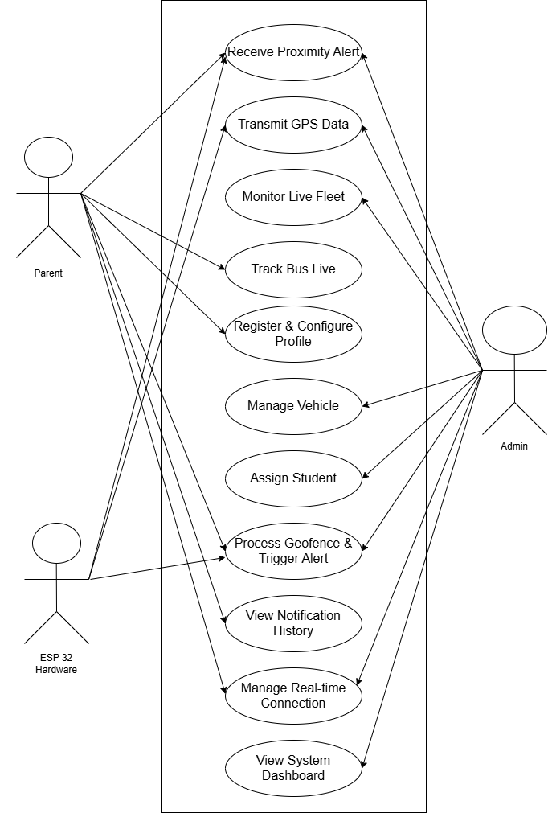

Figure 4:Use-case Diagram Of SmartBuX System

CHAPTER No. 4: Project Design

4.1. System Design
The SmartBuX system has a plan that shows how all the parts work together. This plan is called the Software Design Specification. It talks about how the different components of SmartBuX interact with each other to make sure everything works as it should.
The SmartBuX system is made up of three parts. These parts are the Hardware Layer, the Backend Server and API Layer and the Client Presentation Layer. The Hardware Layer uses things, like ESP32 and GPS. The Backend Server and API Layer uses Node.js, Express and Socket.io. The Client Presentation Layer uses React Native App and React PWA. This way of building the SmartBuX system is called a three-tier architecture. It helps keep everything organized and working smoothly. This design makes sure that everything has its job and does not get mixed up with other things. It also means that the system can be made bigger if we need to like if we want to add Speedo buses. The system can also talk to parts in real time which is very important. The main thing is that the system does all of this without using any paid services from companies that help with sending notifications.
4.1.1. System Components
The system is made up of parts that are connected to each other. These parts are:
- Hardware Integration Module (On-Bus): Manages GPS data acquisition via the NEO-6M module and transmission via HTTP POST by the ESP32 microcontroller.
- Backend Core Server:This is built with Node.js and Express. It does a few things. The Backend Core Server provides REST APIs for managing users. It also handles the WebSocket server. This is for real-time events. The Backend Core Server even executes the core geofencing logic, for the system.
- The Real-Time Communication Engine is really important. It uses Socket.io to work. The Real-Time Communication Engine manages how people connect and stay connected. It also helps people join groups like a group for a bus or a group for admins. The Real-Time Communication Engine makes sure that people, in these groups can talk to each other and share things. This is a two way thing so people can. Get information at the same time. The Real-Time Communication Engine is powered by Socket.io.
- The Data Persistence Layer is where we keep all the information. We use something called MongoDB to store lots of kinds of data like information about users, vehicles, alerts and where things have been in the past. We also use Mongoose ODM to make sure all the data is organized. Follows the rules we set up for it so everything stays nice and structured. The Data Persistence Layer is really important because it helps us keep track of things, like user information, vehicle data and location history and it does this by storing it all in MongoDB.
- Parent Mobile Application (React Native):This is an app that parents can use on their phones. It helps them keep track of things. They can see where their kids are in time get important messages and manage their own accounts. The Parent Mobile Application is special because it works on kinds of phones. The Parent Mobile Application is really useful, for parents.
- Admin Web Portal (React PWA):This is a website that school administrators can use. They can see what is going on with the fleet manage the users and look at the analytics on the Admin Web Portal. The Admin Web Portal is, like a tool for school administrators to use on their computers or phones.
4.1.2. Work Breakdown Structure (WBS)
The WBS decomposes the SmartBuX project into manageable phases and tasks, ensuring systematic development.

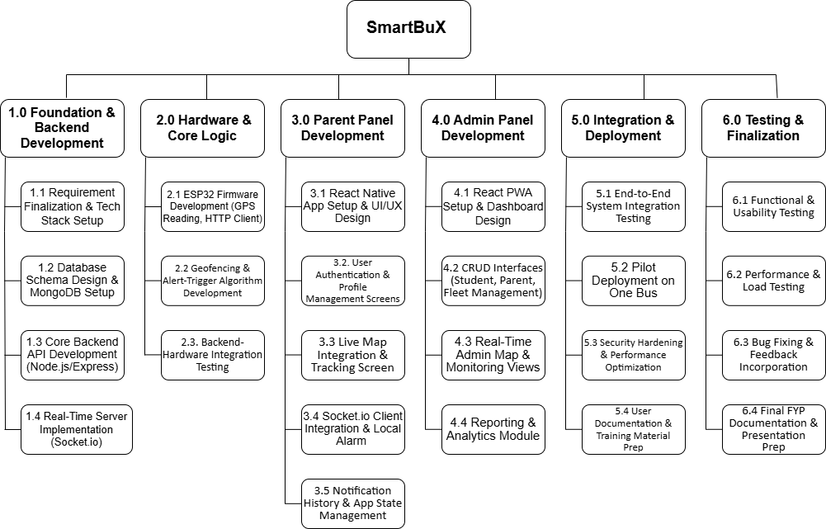

Figure 5:WBS of SmartBuX

4.2. Design Models
4.2.1. Class Diagram (Backend Domain Model)
The class diagram represents the core entities and their relationships within the SmartBuX backend system.
Key Classes:
- User: Abstract class for Parent and Admin. Contains userId, phone, passwordHash, role.
- Parent: Inherits from User. Has associations with multiple Student objects and one PickupLocation. Listens for Alert notifications.
- Student: Linked to one Parent and one Vehicle (Bus). Has studentId, name, grade, pickupTime.
- Vehicle: Represents a school bus. Contains vehicleId, busNumber, deviceId (linked to ESP32), driverName, currentLocation (GeoJSON), status. Associated with a Route.
- LocationUpdate: Time-stamped GPS data (latitude, longitude, speed, timestamp) sent from a Vehicle. Aggregated into location history.
- Alert: Generated when a Vehicle enters a 500m geofence of a Student's PickupLocation. Contains alertId, type, message, distance, triggeredAt, status (sent, read).
- PickupLocation: Geospatial point (coordinates, address) defined by a Parent for a Student.
- Route: Defines a sequence of stops. Has routeId, name, stops[] (GeoJSON).
Relationships:
Inheritance: Parent and Admin ISA User.
Associations:
Parent has 1..* Student.
Student assigned to 1 Vehicle.
Vehicle sends 1..* LocationUpdate.
System creates 1 Alert for a Parent when Vehicle is near PickupLocation.
Vehicle follows 1 Route.
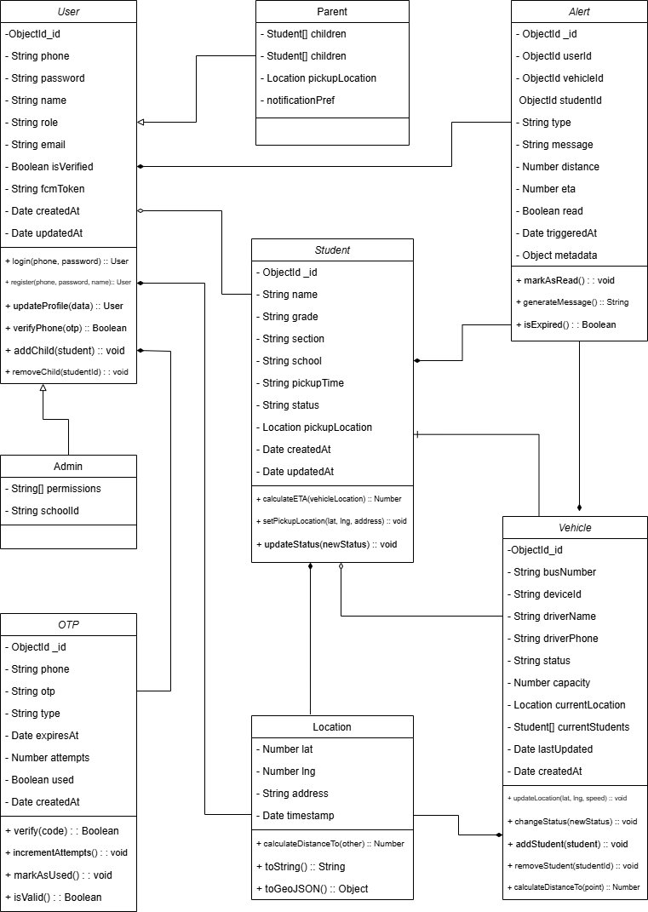

Figure 6: Class Diagram Of Backend
4.2.2. Sequence Diagram: Proximity Alert Trigger
The sequence diagram shows what the SmartBuX system does when it finds a school bus that's close by. It tells the parents away so they know their kids are safe. The SmartBuX system is really good, at detecting a school bus and it alerts parents in real time to keep the students safe with the SmartBuX system.
GPS Data Update
- The ESP32 device installed in the bus collects GPS coordinates from the GPS module.
- The device sends the location data (device ID, latitude, longitude, and speed) to the backend server via an HTTP POST request.
Backend Validation and Storage
- The backend validates the received device ID and identifies the associated vehicle.
- The new vehicle location is stored in the database for tracking and history purposes.
Geofencing Logic Execution
- The backend retrieves all students assigned to the vehicle.
- The system calculates the distance between the bus location and each student’s pickup location.
- The calculated distance is compared with the predefined geofence radius of 500 meters.
Alert Creation
- If the distance is less than or equal to 500 meters, a proximity alert is generated.
- The alert record is saved in the database with relevant details such as student, vehicle, distance, and time.
Parent Notification
- The backend emits a real-time Socket.io event to the respective parent.
- The parent’s mobile application receives the event and triggers a local alarm with sound and vibration.
- The application updates the interface to display alert information.
Alert Acknowledgment
- The parent marks the alert as read in the application.
- The application sends an update request to the backend, and the alert status is updated in the database.
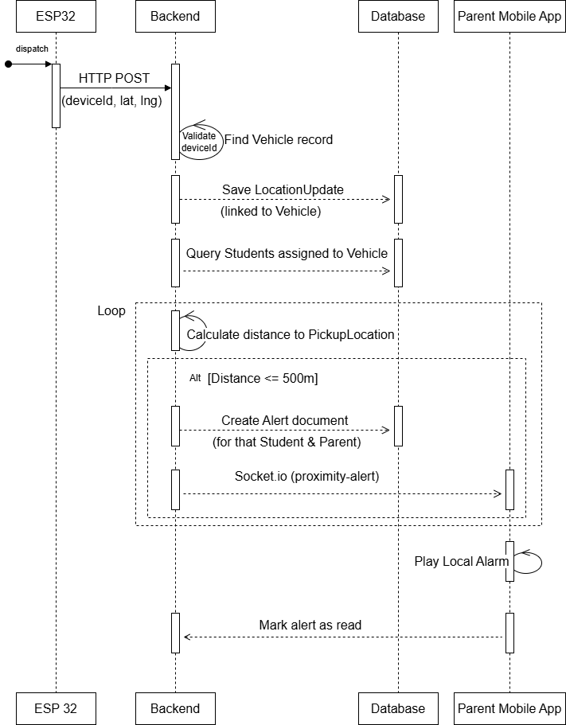

Figure 7:Sequence Diagram: Proximity Alert Trigger
4.2.3. Activity Diagram: Complete System Workflow:
This diagram captures the main workflows of all primary actors in the SmartBuX system: Parent, Admin, and System Backend.
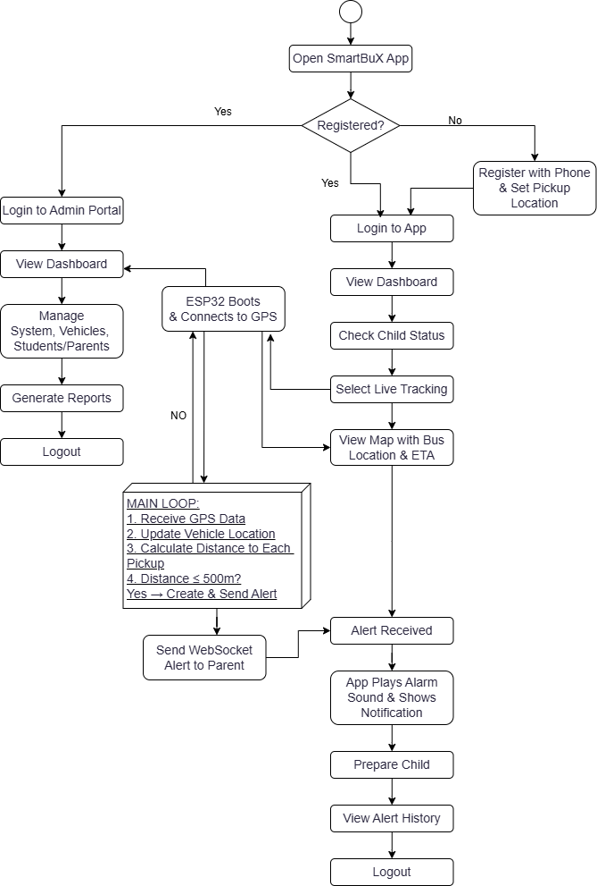

Figure 8:Activity Diagram: Complete System Workflow:
4.3. Data Design
4.3.1. Entity-Relationship Diagram (ERD)
The Entity-Relationship Diagram (ERD) models the core data entities and their relationships for the MongoDB-based Smart School Bus Pick and Drop Management System.
Core Entities & Attributes
users
(_id, phone [UK], passwordHash, name, role, email, pickupLocation (embedded), isVerified, fcmToken, createdAt, updatedAt)
students
(_id, name, grade, section, school, parentId [FK → users], assignedBus [FK → vehicles], pickupTime, status, pickupLocation (embedded), createdAt, updatedAt)
vehicles
(_id, busNumber [UK], deviceId [UK], driverName, driverPhone, currentLocation (embedded GeoJSON), status, capacity, currentStudents[] [FK → students], lastUpdated, createdAt)
alerts
(_id, userId [FK → users], studentId [FK → students], vehicleId [FK → vehicles], type, message, distance, eta, triggeredAt, read, metadata)
otps
(_id, phone, otp, type, expiresAt, attempts, used, createdAt [TTL: 10 minutes])
Cardinality Relationships
- A User can have one or more Students (1:N).
- Each Student must belong to exactly one User (N:1).
- A Student may be assigned to one Vehicle, while a Vehicle can transport many Students (N:1).
- A Vehicle maintains a real-time list of onboard students via currentStudents[] (1:N).
- A User can receive multiple Alerts over time (1:N).
- A Student can generate multiple Alerts based on proximity and events (1:N).
- A Vehicle triggers multiple Alerts as it moves along its route (1:N).
- A User can request multiple OTPs for authentication purposes (1:N).

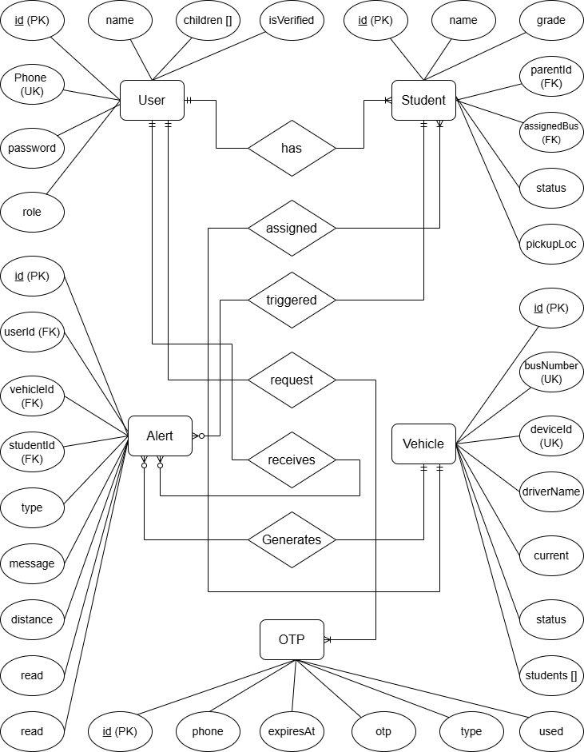

Figure 9:Entity-Relationship Diagram (ERD)

